Supplemental Materials for
Cost-Effectiveness of Community-Based Interventions for Reducing Opioid Overdose and Non-Overdose Deaths: Simulation Modeling of HEALing Communities Study

Table of Contents
Supplement S1. Supplementary methods 3
S1.1. Model structure and simulation setup 3
S1.1.1. Health states 3
S.1.1.2. Model initialization 3
S1.1.3. State transitions and simulation events 3
S1.2. Estimation of prevalence for opioid use health states 5
S1.2.1. Prevalence of OUD 5
S1.2.2. Prevalence of prescription opioid misuse and illicit opioid use (without OUD) 6
S1.2.3. Sex and age distributions of persons with non-medical opioid use 9
S1.3. Modeling of MOUD treatment and recovery 12
S1.3.1. Treatment retention 12
S1.3.2. HCS data for MOUD treatment 12
S1.3.3. Recovery and relapse 13
S1.4. Mortality estimates 13
S1.4.1. Opioid overdose mortality 13
S1.4.2. Modeling the impact of naloxone availability on overdose mortality 14
S1.4.3. Opioid-related non-overdose mortality and other-cause mortality 15
S1.5. Model calibration 17
S1.6. Model input tables 21
S1.7. Probabilistic sensitivity analysis 24
Supplement S2. Simulation scenarios 26
Supplement S3. Economic inputs 27
Supplement S4. Supplementary results 32
References 45

Abbreviations
AIC | Akaike information criterion
BIC | Bayesian information criterion
BUP | Buprenorphine
DSM-5 | Diagnostic and Statistical Manual of Mental Disorders, 5th edition
EBP | Evidence-based practices
HCS | HEALing Communities Study
HEAL | Helping to End Addiction Long-term
HR | Hazard ratio
HUD | Heroin use disorder
MET | Methadone
MOUD | Medications for opioid use disorder, including buprenorphine, methadone, and naltrexone
NAL | Naltrexone
NIDA | National Institute on Drug Abuse
NSDUH | National Survey on Drug Use and Health
OOD | Opioid overdose deaths
OPSiM | Opioid Policy Simulation Model
OTP | Opioid treatment program
OUD | Opioid use disorder
PDMP | Prescription drug monitoring program
PRUD | Pain reliever use disorder
RR | Relative risk
SAMHSA | Substance Abuse and Mental Health Services Administration
SMR | Standardized mortality ratio

Supplement S1. Supplementary methods

S1.1. Model structure and simulation setup
The Opioid Policy Simulation Model (OPSiM) is a microsimulation model that simulates the course and outcomes of non-medical opioid use at the individual level. It was calibrated to community-level data from the HEALing Communities Study¹.

S1.1.1. Health states
The model consists of the following five mutually exclusive health states that represent five unique subgroups of people who use opioids non-medically (Supplementary Figure 1):
- Prescription Opioid Misuse Only (without Illicit Opioid Use): representing individuals who use prescription opioids non-medically without concurrent use of illicitly manufactured opioids and without meeting the Diagnostic and Statistical Manual of Mental Disorders, 5th edition (DSM-5) criteria for diagnosis of opioid use disorder (OUD).
- Illicit Opioid Use: representing individuals who use illicitly manufactured opioids, possibly with concurrent non-medical use of prescription opioids, without meeting the DSM-5 criteria for diagnosis of OUD.
- OUD without Medications for OUD Treatment (or “OUD state” in short): representing individuals who meet the DSM-5 criteria for diagnosis of OUD and do not receive treatment with an MOUD, defined as the use of an FDA-approved drug (buprenorphine, methadone, or naltrexone) for treating OUD,² possibly in conjunction with counseling and behavioral therapies.
- Recovery on MOUD (or “MOUD state” in short): representing individuals who have OUD and are undergoing MOUD treatment.
- Recovery not on MOUD (or “recovery state” in short): representing individuals who have recovered after MOUD treatment or through natural recovery and are assumed to be abstinent from opioids. Individuals in this state are considered to have the same risk of future opioid misuse and health outcomes as the general population.

In addition to the health states for opioid misuse, the OPSiM also tracks individual-level attributes such as sex, age, type of MOUD in the current treatment episode (i.e., buprenorphine, methadone, or naltrexone), time since the start of the current episode of treatment (if receiving MOUD), and the time since the last month of treatment (in the event of relapse after discontinuation of MOUD).

S.1.1.2. Model initialization
The simulation model was initialized at the beginning of year 2012 and followed a warm-up period until the year 2017. The purpose of the warm-up period was to allow the model to reach a relatively stable distribution of the simulated population across health states and attributes before starting the formal simulation analysis in 2017. The initial population consisted of individuals in the health states of Prescription Opioid Misuse, Illicit Opioid Use, and OUD (without MOUD Treatment). The initial size of each subpopulation was based on the estimated prevalence of each health state in 2017 at the community level (Supplement S1.2). Individuals’ age and sex were sampled following the distributions conditioned on their health state (Supplement S1.2.3). We calibrated a multiplier parameter for the initial size of the Prescription Opioid Misuse state in 2012 and monthly incidence parameters for Prescription Opioid Misuse and Illicit Opioid Use states such that the steady-state distribution by the end of the warm-up period matched the prevalence estimates for all health states if the year 2017 for New York and Ohio communities, and 2018 for Massachusetts.

S1.1.3. State transitions and simulation events
Individuals enter the model in the health state of Prescription Opioid Misuse or Illicit Opioid Use (without OUD) health state. Individuals in the Prescription Opioid Misuse state may transition to the Illicit Opioid Use state but not vice versa. Individuals in either of these two health states may develop OUD, i.e., transition to the OUD without MOUD Treatment state. From the OUD without MOUD state, individuals may initiate treatment and transition to the MOUD state, or recover without use of MOUD, transitioning to the Recovery state directly. Individuals in the MOUD state may discontinue treatment, with the discontinuation rate dependent on the type of MOUD treatment and the number of previous treatment episodes (see Supplement S1.3 for more details). Upon discontinuing MOUD treatment, the individual may either relapse (i.e., transition back to the OUD without Treatment state) or recover (i.e., transition to the Recovery state). Individuals in the recovery state may also relapse and transition to the OUD without treatment state. In all health states except the Recovery state, individuals may overdose and die with the overdose mortality rate dependent on the individual’s current health state as well as history, such as the time since the most recent relapse or the duration of the current MOUD treatment episode. Finally, individuals are subject to two other types of mortality: opioid-related non-overdose mortality and other-cause mortality (Supplement S1.4). The model captures the effect of naloxone on reducing the fatality of overdoses through the overall number of naloxone kits circulating in the community.

The simulation model has a cycle length of one month. That is, individuals can transition to a new health state on a monthly basis. In each model cycle, the following events are simulated sequentially:
            - Simulate each individual’s transition between health states following the transition probabilities. Individual attributes are updated.
            - Simulate overdose event and overdose death outcomes for all individuals except those in the Recovery state, following a probabilistic overdose pathway (Supplementary Figure 1)
            - If an individual does not experience an overdose or if the overdose is nonfatal, determine the individual’s death outcome subject to opioid-related non-overdose mortality and other-cause mortality.
            - If an individual survives the current model cycle, proceed to the next cycle.
            - Create new individuals entering the model from the Prescription Opioid Misuse and Illicit Opioid Use states. Their health state remains unchanged until the next model cycle.

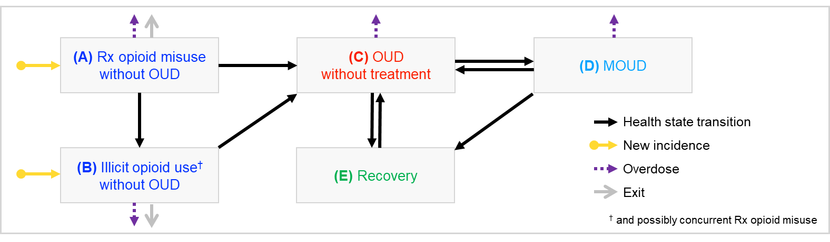
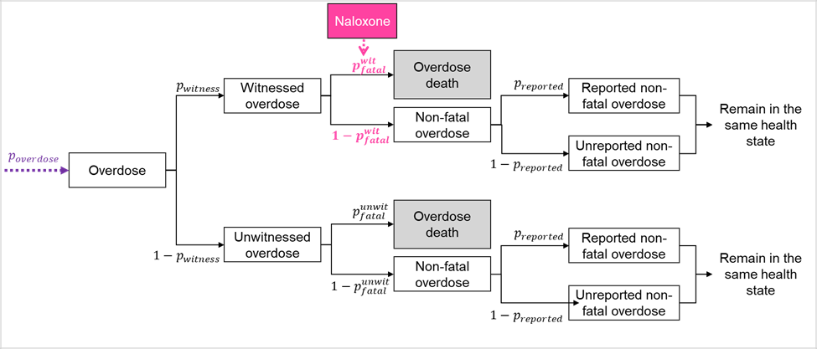
Supplementary Figure 1. Model schematic of the Opioid Policy Simulation Model (OPSiM) showing transitions between different health states and overdose pathways.
Abbreviations: OUD, opioid use disorder; MOUD, medication for opioid use disorder; Rx, prescription.
Note: Opioid overdose death is possible from all states except ‘recovery’. Opioid-related non-overdose death is possible from all states except ‘prescription opioid misuse without OUD’ and ‘recovery’. Other-cause death is possible from all states. Opioid-related non-overdose death, other-cause death, and self-transitions are not shown.

S1.2. Estimation of prevalence for opioid use health states

S1.2.1. Prevalence of OUD
To estimate the prevalence of OUD in each simulated community (Supplementary Table 1), we extrapolated the estimates of OUD prevalence among the community’s Medicaid population using data from the National Survey on Drug Use and Health (NSDUH) and the published literature.³ Given that the estimates of OUD prevalence in Medicaid beneficiaries aged 18-64 years are based on the OUD diagnosis in the Medicaid claims data, this approach made additional adjustment in three sequential steps to account for: (1) Medicaid beneficiaries who do not interact with the healthcare system (and thus had no claims information) and potential misclassifications of OUD diagnosis in medical claims, using literature on the healthcare utilization ratio in Medicaid population⁴ and misclassification rate of diagnosis in claims;^{5,6} (2) individuals with OUD in the non-Medicaid population, using the relative differences in OUD prevalence between the Medicaid and non-Medicaid populations at the state level as estimated from the NSDUH;⁷ and (3) individuals of other age groups (i.e., 12-17 years and aged 65 and older), using the relative size of individuals with OUD between different age groups as estimated from NSDUH.^{7,8} Due to restrictions from the data use agreement of this study, we are unable to report community-specific estimates; instead, we summarize the average prevalence estimates among the simulated communities by urban and rural status in Table S1.1.
Table S1.0. Communities simulated by urban/rural status and state
Stateª | Rural | Urban
Massachusetts | Athol/Greenfield/Montague/Orange | Brockton, Holyoke, Lawrence, Lowell, Pittsfield, Salem, Springfield, Weymouth
New York | Chautauqua County, Sullivan County | Broome County, Orange County, Ulster County
Ohio | Ashtabula County, Athens County, Huron County, Ross County, Scioto County | Allen County, Cuyahoga County, Franklin County, Greene County, Hamilton County, Lucas County, Stark County
HCS communities in Massachusetts were cities/towns, whereas HCS communities in New York and Ohio were generally entire counties.

Supplementary Table 1. Estimated prevalence of OUD in 26 simulated urban and rural communities, 2017-2022.
 | Mean (min − max) prevalence of OUDª
Year | Urban, N = 18 | Rural, N = 8
2017^{b} | 0.032 (0.020 − 0.042) | 0.058 (0.034 − 0.114)
2018 | 0.048 (0.020 − 0.111) | 0.064 (0.038 − 0.116)
2019 | 0.048 (0.021 − 0.106) | 0.067 (0.038 − 0.127)
2020 | 0.046 (0.020 − 0.102) | 0.066 (0.038 − 0.134)
2021 | 0.045 (0.020 − 0.103) | 0.069 (0.038 − 0.144)
2022 | 0.046 (0.020 − 0.109) | 0.069 (0.037 − 0.145)
ª Among individuals aged 12 years and older.
^{b} Estimates for 2017 were unavailable for communities in Massachusetts.

S1.2.2. Prevalence of prescription opioid misuse and illicit opioid use (without OUD)
Base estimate
Data on the prevalence of prescription opioid misuse and illicit opioid use are unavailable from claims data. We estimated the community-level prevalence of prescription opioid misuse without OUD and of illicit opioid use without OUD using data from the NSDUH. The NSDUH is an annual survey that asks respondents questions about their behaviors, misuse of prescription opioids, and use of illicit opioids. Data is available for the nation as a whole, as well as by state and substate. However, the variables available for analysis are restricted to smaller geographic areas. Furthermore, state and substate-level data are available as annual averages over two and three-year periods, respectively. Whenever possible, we used data from the smallest geographic area available. When data were unavailable at the substate level, we relied on state-level data. We used the average of substate-level data from 2016-2018⁹ to represent sub-state level prevalence in 2017 and the average of state-level data from 2016-2017 and 2017-2018 to represent state-level prevalence in 2017.^{10,11}

Supplementary Figure 2 shows our conceptual model that maps the variables available in the NSDUH data to the health states for different types of opioid use defined for our simulation model. Given that the NSDUH tracks prescription pain reliever misuse, heroin use, and opioid use disorder, separately, it resulted in six elements, which were then grouped as: Prescription Opioid Misuse without OUD (element 1), Illicit Opioid Use without OUD (elements 2 and 3), and OUD (elements 4, 5, and 6). Note that because NSDUH does not include a variable explicitly for illicitly manufactured opioid use, we used the variable for heroin use as a proxy for illicitly manufactured opioid use. We illustrate our approach for estimating substate-level prevalence for the Prescription Opioid Misuse and Illicit Opioid Use states using the available estimates from NSDUH in Supplementary Tables 2 and 3 below.

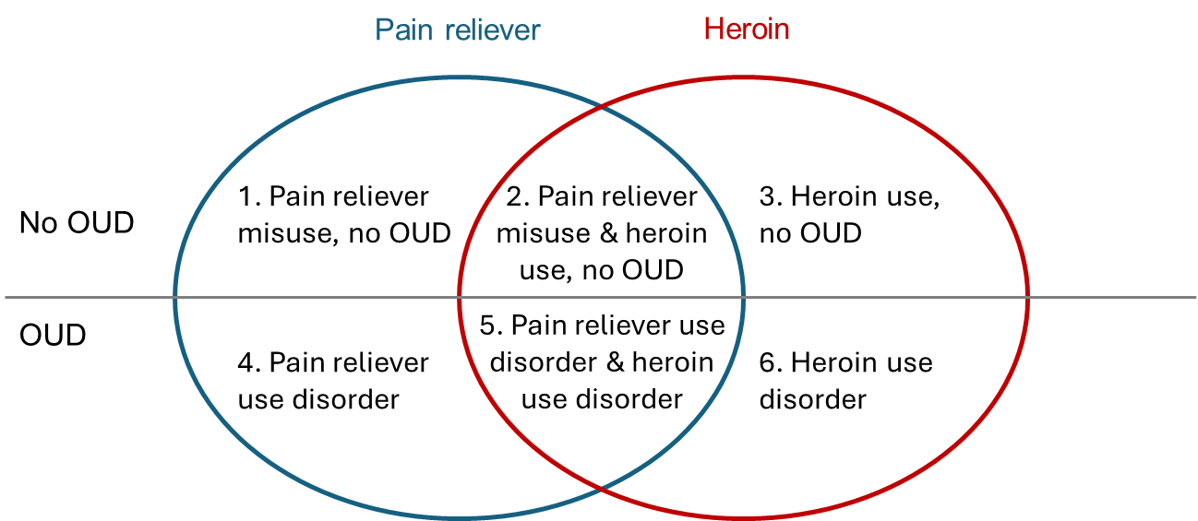
Supplementary Figure 2. Conceptual model of mapping variables for opioid uses from NSDUH to health states in OPSiM.
Note: This figure is only for illustrating the conceptual relationship between the multiple states and the size of each subregion does not imply the relative size of the corresponding subpopulation.
Supplementary Table 2. Worksheet to demonstrate the calculation of the substate-level past-year prevalence of prescription opioid misuse without OUD during the period 2016-2018 for an example community (not in the HEALing Communities Study)ª using data from NSDUH.
Steps | Variable notation | Example value  for 2016–2018 | Source
State average annual estimate of number of individuals with misuse of pain relievers^{b} | g | Average of:  484,000 (2016–2017) and 430,000 (2017–2018)  = 457,000 | SAMHSA,^{12,13} variable PNRMYR = 1
State annual average estimate of number of individuals with misuse of pain relievers but no heroin use and no OUD^{b} | h | 383,000 (2016–2017) and 301,000 (2017–2018) = 342,000 | Prevalence tables provided by the National Institute on Drug Abuse on March 9, 2020
Proportion of those who misuse pain relievers who do not use heroin or have OUD | h/g | 0.748
Substate annual average estimate of past-year misuse of pain relievers | i | 4.834% | SAMHSA,⁹ Table 12
Estimated substate prevalence of past year misuse of pain relievers, but no heroin use and no OUD | h/g × i | 3.618%^{c}
ª Montgomery County, Ohio.
^{b} Unavailable from NSDUH substate data.
^{c} Unadjusted for underreporting in NSDUH.

Supplementary Table 3. Worksheet to demonstrate the calculation of the substate-level past-year prevalence of illicit opioid use without OUD during the period 2016-2018 for an example community (not in the HEALing Communities Study)ª using data from NSDUH.
Steps | Variable notation | Example value  for 2016–2018 | Source
State average annual estimate of number of individuals with past-year use of heroin (includes use disorder and misuse)^{b} | a | Average of:  51,000 (2016–2017) and 56,000 (2017–2018)  = 53,500 | SAMHSA;^{12,13} variable HERYR = 1
State average annual estimate of number of individuals who use heroin in the past year but did not have OUD^{b} | y | Average of:  8,000 (2016–2017) and 15,000 (2017–2018)  = 11,500 | SAMHSA;^{12,13} variable HERYR = 1 and variable UDPYOPI = 0
Proportion of heroin users that do not have OUD | y/a | 0.215
Substate annual average estimate of percent of population with past-year heroin use | c | 0.443% | SAMHSA⁹ Table 9
Estimated substate prevalence of heroin use without OUD | y/a × c | 0.095%^{c}
ª Montgomery County, Ohio.
^{b} Unavailable from NSDUH substate data.
^{c} Unadjusted for underreporting in NSDUH.

Following the above calculation method, we estimated the prevalence (as a percentage of the population aged 12 years and older in a community) for the Prescription Opioid Misuse and the Illicit Opioid Use health states during the periods 2016-2018 and 2018-2019 (Supplementary Table 4). We then multiplied the estimated prevalence by community population counts for the age of 12 years and above to yield estimate of the number of people in each health state respectively.
Supplementary Table 4. Estimated prevalence of prescription opioid misuse without OUD and illicit opioid use without OUD in simulated urban and rural communities, 2016-2018 and 2018-2019.
 | Mean (min − max) prevalence of opioid use without OUDª
 | Prevalence of prescription opioid misuse without OUD^{b} |  |  | Prevalence of illicit opioid use without OUD†
Period | Urban, n = 18 | Rural, n = 8 |  | Urban, n = 18 | Rural, n = 8
2016-2018 | 0.067 (0.046 − 0.124) | 0.084 (0.061 − 0.125) |  | 0.007 (0.001 − 0.025) | 0.006 (0.002 − 0.019)
2018-2019 | 0.072 (0.027 − 0.181) | 0.064 (0.034 − 0.141) |  | 0.007 (0.001 − 0.027) | 0.005 (0.001 − 0.021)
ª Among individuals aged 12 years and older.
^{b} Individuals who use both illicit and prescription opioids without OUD are counted in the Illicit Opioid Use without OUD health state.

Adjustment for underreporting from NSDUH
NSDUH relies on self-reporting of drug use and includes only the non-institutionalized population. Accordingly, the prevalence of the non-medical use of prescription and illicitly manufactured opioids without OUD is likely underestimated.^{14,15} To account for this underreporting, we applied a multiplier method to adjust the community-specific prevalence estimates from NSDUH. To our knowledge, county- or even state-level data on the prevalence of prescription opioid misuse and illicit opioid use without OUD are unavailable from other sources. Accordingly, we relied on data on the magnitude of underestimation of OUD to estimate the magnitude of underreporting of these measures, assuming that underestimation is larger for illicit use vs. prescription opioid misuse.

First, we calculated a multiplier for the underestimation of OUD prevalence by comparing our community-specific OUD prevalence estimates in 2018 with substate-level prevalence estimates derived from NSDUH during the period 2016-2018.⁹ The latter estimates were derived from data on the prevalence of past-year pain reliever use disorder (elements 4 and 5 of Supplementary Figure 2, and the prevalence of past-year heroin use disorder (elements 5 and 6 of Supplementary Figure 2), accounting for the possibility of double-counting persons with both past-year pain reliever use disorder and heroin use disorder (element 5 of Supplementary Figure 2). That is:

OUD = [pain reliever use disorder (PRUD)] + [heroin use disorder (HUD)] − (PRUD AND HUD).

We then derived a multiplier for each type of opioid use, assuming that underreporting of illicit opioid use without OUD is less than underreporting of OUD and higher than underreporting of prescription opioid misuse without OUD. Specifically, we assumed that the multipliers to account for underreporting of prescription opioid use without OUD and of illicit opioid use without OUD are one-third (1/3) and two-thirds (2/3) the size of the multiplier that accounts for underreporting of OUD, respectively.¹⁶ An example of the calculation of these multipliers is shown in Supplementary Table 5. The average multipliers for simulated urban and rural communities are presented in Supplementary Table 6.
Supplementary Table 5. Worksheet to demonstrate the calculation of multipliers for the underestimation of the prevalence of pain reliever misuse without OUD and illicit opioid use without OUD from NSDUH.
Steps | Variable notation | Source
Annual estimate of the number of individuals who have OUD in a given community | j | Supplement S1.2.1
Estimate of the size of the population aged ≥ 12 years in a given community | k | American Community Survey¹⁷
Substate annual average estimate of proportion of individuals who have opioid dependence or abuse in the past year | m | SAMHSA;⁹ variable UDPYOPI = 1
Multiplier for underreporting of OUD prevalence | (j/k)/m
Multiplier for underreporting of prescription opioid misuse only | 1/3 × ((j/k)/m – 1) + 1
Multiplier for underreporting of illicit opioid use without OUD | 2/3 × ((j/k)/m – 1) + 1

Supplementary Table 6. Estimated multipliers for the underestimation of the prevalence of pain reliever misuse and of illicit opioid use without opioid use disorder in NSDUH in simulated urban and rural communities, by period.
 | Mean (min − max) multiplier for underestimation of prevalence of opioid misuse in NSDUH
 | Prescription opioid misuse without or OUD |  |  | Illicit opioid use without OUD
Period | Urban, n = 18 | Rural, n = 8 |  | Urban, n = 18 | Rural, n = 8
2016-2018 | 2.61 (1.42 − 5.26) | 2.78 (1.90 − 4.08) |  | 4.21 (1.84 − 9.53) | 4.56 (2.80 − 7.16)
2018-2019 | 3.29 (1.29 − 7.66) | 2.95 (1.68 − 5.88) |  | 5.59 (1.57 − 14.33) | 4.90 (2.36 − 10.76)

S1.2.3. Sex and age distributions of persons with non-medical opioid use
As noted in Supplement S1.1.3, the sex and initial age of a simulated individual in 2017 were sampled from distributions. Data were unavailable to estimate the joint distribution by sex and age, so we assumed that for each health state, the age distribution did not vary among males and females.

Sex distributions
Data on the sex of individuals with non-medical use of opioids were unavailable at the community level. Accordingly, we relied on state-level data from NSDUH. For each opioid-use-related health state and each (US) state of the simulated communities (i.e., Massachusetts, New York, Ohio), we combined estimates from the 2016-2017 and 2017-2018 state-level data to obtain the best estimate of the sex distribution in 2017. The details for each health state are provided below, and the estimates are summarized in Supplementary Table 7.

OUD state: The distribution of the population with OUD in 2017 by sex was obtained from the number reporting past year opioid dependence or abuse in the 2016-2017 and 2017-2018 state-level NSDUH data.^{12,13}

Prescription Opioid Misuse Only (without Illicit Opioid Use) state: The sex distribution of the population that misuses prescription opioids only (without illicit opioid use) in 2017 was obtained from 2016-2017 and 2017-2018 state-level NSDUH data provided by the National Institute on Drug Abuse (NIDA); estimates for this particular group were unavailable from publicly available NSDUH state-level data.

Illicit Opioid Use without OUD state: The sex distribution of the population that uses illicit opioids without OUD in 2017 was unavailable from publicly available NSDUH state-level data. Due to small numbers, the estimates were also not available by special request from NIDA. Accordingly, we assumed that the sex distribution of the group of interest, those who use illicit opioids without OUD, would be the same as the sex distribution of individuals reporting past-year heroin use (i.e., with or without OUD); we estimated the latter from publicly available 2016-2017 and 2017-2018 NSDUH state-level data.^{12,13}
Supplementary Table 7. Estimated proportion of those with OUD, those who misuse prescription opioid without OUD, and those who use illicit opioids without OUD who are female in Massachusetts, New York, and Ohio in 2017.
 | Proportion female in 2017 by health state
State | OUD | Prescription opioid misuse without OUD | Illicit opioid use without OUD
Massachusetts | 0.156 | 0.496 | 0.342
New York | 0.313 | 0.505 | 0.273
Ohio | 0.374 | 0.458 | 0.324

Age distributions
Similar to data on the distribution by sex, data on the age group of individuals with non-medical use of opioids were unavailable at the community level. We largely relied on data from NSDUH to inform these distributions for each opioid-use-related health state and each (US) state of the simulated communities (i.e., Massachusetts, New York, Ohio), combining estimates from the 2016-2017 and 2017-2018 state-level data to obtain the best estimate of the age distribution in 2017. The details for each health state are provided below, and the estimates are summarized in Supplementary Tables 8 – 10 below.

OUD state: As described in section Supplement 1.2.1, we derived estimates of the number of people in each community with OUD for the following age groups: 12-17 years, 18-64 years, and 65 years and older. From these estimates, we estimated a community-specific distribution of the population with OUD by age group. Because the middle age group spanned a large age group (i.e., 18-64 years), we used state-level data from the 2016-2017 and 2017-2018 state-level NSDUH reports^{12,13} to estimate the distribution by smaller age groups within the 18-64 age range. The resulting age distributions are shown in Supplementary Table 8.
Supplementary Table 8. Estimated distribution of populations with OUD in Massachusetts, New York, and Ohio in 2017 by age group.
 | Proportion by age group
State | 12-17 yearsª | 18-25 years | 26-34 years | 35-49 years | 50-64 years | ≥ 65 yearsª
Massachusetts | $$p_{12}$$ | 0.156 × (1-$p_{12}$-$p_{65}$) | 0.052 × (1-$p_{12}$-$p_{65}$) | 0.252 × (1-$p_{12}$-$p_{65}$) | 0.541 × (1-$p_{12}$-$p_{65}$) | $$p_{65}$$
New York | $$p_{12}$$ | 0.151 × (1-$p_{12}$-$p_{65}$) | 0.285 × (1-$p_{12}$-$p_{65}$) | 0.301 × (1-$p_{12}$-$p_{65}$) | 0.263 × (1-$p_{12}$-$p_{65}$) | $$p_{65}$$
Ohio | $$p_{12}$$ | 0.181 × (1-$p_{12}$-$p_{65}$) | 0.235 × (1-$p_{12}$-$p_{65}$) | 0.363 × (1-$p_{12}$-$p_{65}$) | 0.221 × (1-$p_{12}$-$p_{65}$) | $$p_{65}$$
ª Estimates are community specific.

Prescription Opioid Misuse Only (without Illicit Opioid Use) state: The age group distribution of the population that misuses prescription opioids only (without illicit opioid use) in 2017 was obtained from 2016-2017 and 2017-2018 state-level NSDUH data provided by NIDA; estimates for this particular group were unavailable from publicly available NSDUH state-level data. Data were provided for the age groups 12-19 years, 20-29 years, 30-49 years, and ≥ 50 years (Supplementary Table 9).
Supplementary Table 9. Estimated distribution of populations in Massachusetts, New York, and Ohio in 2017 who misuse prescription opioids only by age group.
 | Proportion by age group
State | 12-19 years | 20-29 years | 30-49 years | ≥ 50 years
Massachusetts | 0.147 | 0.191 | 0.449 | 0.212
New York | 0.096 | 0.308 | 0.335 | 0.261
Ohio | 0.109 | 0.241 | 0.401 | 0.250

Illicit Opioid Use without OUD state: The distribution of the population that uses illicit opioids without OUD in 2017 was unavailable by age group from publicly available NSDUH state-level data. Due to small numbers, the estimates were also not available by special request from NIDA. Accordingly, we assumed that the distribution by age group of those who use illicit opioids without OUD would be the same as the distribution for those who reported using heroin in the past year with or without OUD. The age distribution for the latter was estimated from 2016-2017 and 2017-2018 state-level NSDUH data^{12,13} (Supplementary Table 10).
Supplementary Table 10. Estimated distribution of populations in Massachusetts, New York, and Ohio in 2017 who use illicit opioids without OUD by age group.
 | Proportion by age group
State | 12-17 years | 18-25 years | 26-34 years | ≥ 35 years
Massachusetts | 0.014 | 0.068 | 0.110 | 0.808
New York | 0.013 | 0.234 | 0.247 | 0.506
Ohio | 0.019 | 0.204 | 0.213 | 0.565

Assignment of exact age with an age group
For all health states, simulated individuals were assigned an exact age within an age group by drawing from the distribution by single year of age within each age group. Absent other data to inform these distributions, we used data on opioid overdose deaths in 2017 by single year of age, obtained from CDC WONDER.¹⁸

S1.3. Modeling of MOUD treatment and recovery

S1.3.1. Treatment retention
We first digitized the Kaplan-Meier curve for treatment retention published in Morgan et al. (2018)¹⁹ and fitted the extracted data points to four parametric survival models commonly used in survival analysis. The survival function and parameters for each distribution are as follows:
- Exponential distribution: $S\left(t\right)=\exp\left(-λt\right)$: Shape parameter=$λ$;
- Weibull distribution: $S\left(t\right)= {\exp{(\left(-λt\right)}}^{p})$: Shape parameter=$λ,$scale parameter=p;
- Log-logistic distribution: $S\left(t\right)= \frac{1}{{1+(λt)}^{\frac{1}{γ}}}$: Shape parameter= $λ,$scale parameter=γ;
- Gompertz distribution: $S\left(t\right)=\exp\left[{-λg}^{-1}\left(\exp\left(gt\right)-1\right)\right]$: Shape parameter= $λ,$scale parameter=γ.
We used the published Kaplan-Meier curve for sublingual or oral mucosal buprenorphine/naloxone treatment, which had the largest sample size in Morgan et al. (2018).¹⁹ The best fitting parametric survival distributions were selected based on goodness-of-fit metrics (Akaike information criterion [AIC], Bayesian Information Criterion [BIC]), as well as visual inspections to ensure reasonable extrapolation beyond the limited follow-up periods. A comparison of goodness-of-fit among survival distributions is listed in Supplementary Table 11, demonstrating that the log-logistic model outperformed other parametric survival models. The best-fitted parameters for the log-logistic model were found to be shape parameter = 0.013, and scale parameter = 0.986.
Supplementary Table 11. Goodness-of-fit of parametric survival models for treatment retention.
 | Survival models
Goodness-of-fit | Exponential | Weibull | Log-Logistic | Gompertz
AIC | -364.15 | -763.20 | -1035.83 | -782.65
BIC | -358.04 | -754.03 | -1026.67 | -773.48

We used the best fitted log-logistic model, $S(t)$, as a common baseline parametric survival model to determine the treatment discontinuation risk. For a given individual in the MOUD state, the time to treatment discontinuation was further adjusted by the number of completed treatment episodes, as a previous study has shown that patients with more treatment episodes were more likely to be retained in treatment.²⁰ The hazard ratios of time to treatment discontinuation by the number of previous treatment episodes $HR_{n}^{d}$ are in Supplement S1.6 (Supplementary Table 16). To compute an individual’s monthly probability of treatment discontinuation, we further adjusted for the type of treatment with a coefficient $K_{med}$ that was determined through model calibration:
$$p_{discontinue}\left(t\right)=\frac{{S\left(t\right)}^{{HR}_{n}^{d}} - {S\left(t+1\right)}^{{HR}_{n}^{d}}}{{S\left(t\right)}^{{HR}_{n}^{d}}}×K_{\text{med}},$$
where $HR_{n}^{d}$ represents the hazard ratio for patients who had completed $n$ treatment episodes, and $K_{med}$ represents an adjusting scalar by the treatment type (i.e., buprenorphine, methadone, naltrexone). The values of $K_{med}$ were found through calibration. All parameter values are presented in Supplement S1.6 (Supplementary Table 16).

S1.3.2. HCS data for MOUD treatment
We estimated the community-level use of buprenorphine, methadone, and naltrexone by year from multiple sources. Buprenorphine use among residents of each community was informed by the state’s drug monitoring program (PDMP) data, whereas methadone and naltrexone use were informed by the state’s Medicaid claims data. Estimates of community-level methadone and naltrexone use among people who are not Medicaid beneficiaries were unavailable. Therefore, we estimated total methadone use in each community by inflating the estimates among the Medicaid population by the estimated proportion of all methadone patients who are Medicaid beneficiaries from each state’s Opioid Treatment Program (OTP) data. For naltrexone, we assumed that the proportion of all naltrexone in a given community that is among Medicaid beneficiaries is the same as the proportion of all buprenorphine use in that community that is among Medicaid beneficiaries.

We also obtained estimates from HCS of the number of people that have been retained on each MOUD for at least 180 days in each community (“treatment retention”). Estimates for treatment retention on buprenorphine were obtained from PDMP data. Estimates for methadone and naltrexone were obtained from Medicaid claims data; we assumed that the proportion of past-year methadone and past-year naltrexone users retained for 180 days among the total population is the same as observed in the Medicaid population.

S1.3.3. Recovery and relapse
Upon the discontinuation of MOUD treatment, individuals may recover (i.e., transition to the Recovery state that assumes no active opioid use) with a recovery probability (conditioned on treatment discontinuation), or they may relapse (i.e., transition to the OUD state). For individuals who discontinued MOUD treatment more than six months since the initiation of the current episode, we used the estimate of recovery probability $p_{recover}$ upon treatment discontinuation based on a longitudinal cohort study of OUD treatment outcomes.²¹ For those who discontinued MOUD treatment before achieving six-month retention, we bounded the recovery probability such that the unconditioned recovery probability $p_{discontinue}\left(t\right)*p_{recover}$ (i.e., through MOUD treatment with a short duration) was not lower than the natural recovery probability without MOUD. The natural recovery probability was estimated based on the per person-year remission rate for people with substance use disorder who did not receive MOUD, using data from a meta-analysis.²²

Individuals in the Recovery state may relapse, transitioning to the OUD state. Similar to the calculation of the monthly treatment discontinuation probability, the probability of relapse was calculated from the baseline survival function for the recovery duration (i.e., time to relapse) that was assumed to follow a Weibull distribution.^{23,24} For subsequent recovery episodes, as a long-term observational study showed that the abstinence period tended to last longer in subsequent attempts,²⁵ we adjusted the survival function for time to relapse with hazard ratio $HR_{n}^{r}$ by the number of completed treatment episodes.²⁶ All parameter values are presented in Supplement S1.6 (Supplementary Table 16).

S1.4. Mortality estimates

S1.4.1. Opioid overdose mortality
The probability that an individual would experience death from an overdose depended on multiple parameters along the opioid overdose pathway (Supplementary Figure 1), including the overdose probability, the probability of the overdose being witnessed, and the probability of the overdose being fatal (depending on whether it was witnessed). All parameter values are presented in Supplement S1.6 (Supplementary Table 16). The probability of the overdose being witnessed was based on estimates from Zang et al. (2022)²⁷, and the other two probability parameters were determined as follows:

Overdose probability: Considering the lack of data for comprehensive estimates of all overdose events (as the only information for non-fatal overdoses available was based on the observed overdoses from hospital inpatient and emergency department data), we did not further differentiate the probability of overdose by OUD and MOUD states during calibration. That is, we assumed that the OUD and MOUD states had the same probability of overdose for calibration but differentiated the fatal probability conditioned on an overdose (see next paragraph) between these two states to simplify the parameterization. In addition, we assumed that the Prescription Opioid Misuse and Illicit Opioid Use states had a lower risk of overdose compared to OUD and MOUD states. Both the baseline overdose probability and the relative risk values were calibrated.

Probability of the overdose being fatal (“fatal probability”): We specified a baseline value of fatal probability, $p_{fatal}^{base}$, for the OUD state up to the year 2017. To capture the growing trend in opioid overdose deaths, we adjusted the fatal probability with a time-dependent factor, $δ(t)$, which followed a linear trend from 2017-2019 and year-specific scalars for 2020-2024 to account for the rapid changes since the COVID-19 pandemic.

For other health states, the fatal probability was determined by multiplying the baseline value $p_{fatal}^{base}$ by a relative risk that depended on the individual’s current health state, $RR\left(state\right)$. Specifically,
- For the Prescription Opioid Misuse and Illicit Opioid Use states, the relative risks were calibrated separately.
- For the MOUD state, relative risks for buprenorphine and methadone, during the first month of treatment and after the first month, were estimated from a published systematic review and meta-analysis²⁸. Due to the lack of existing estimates for naltrexone, we assumed the same relative risks as those for buprenorphine (an optimistic assumption).
- Within the first month of relapse from the Recovery (without MOUD) state, we assumed the same relative risk as in the first month of relapse from MOUD with buprenorphine.

If the overdose was not witnessed, the overall fatal probability after accounting for all adjustments was determined as follows:
$$p_{fatal}^{unwit}=p_{\text{fatal}}^{base}⋅RR\left(state\right).$$

A death from overdose could potentially be averted if naloxone was available at the overdose event. Therefore, we allowed reduction in the fatal probability due to naloxone being distributed in the community. That is, we included a relative risk factor accounting for the naloxone availability in the community, $RR_{naloxone}$, when determining the fatal probability in the event of a witnessed overdose:
$$p_{fatal}^{wit}=p_{\text{fatal}}^{base}⋅RR\left(state\right)⋅RR_{naloxone}(t).$$

The next subsection describes the details of the parameterization for $RR_{naloxone}$ based on the number of naloxone kits circulated in the community.

S1.4.2. Modeling the impact of naloxone availability on overdose mortality
We used data collected by the HCS on the number of naloxone kits distributed in each community through pharmacies²⁹ and community-based programs, aggregated for each year (Supplementary Table 12). Data on the number of kits distributed through community-based programs were missing for 2017 and 2018. We therefore estimated the number by extrapolating backwards, following the same linear trend observed over the period for which the data were available.

As a harm reduction strategy, increasing the availability of naloxone in the community can help reverse overdoses thus prevent overdose mortality. To capture the impact of naloxone availability, we followed a model used in previously published studies^{30,31} that assumed the reduction in mortality, $δ(t)$, increased with the number of naloxone kits available in the community, $N_{\text{naloxone}}(t)$, and has the following mathematical form:
$$δ(t)=c\left(1-\exp\left(-\frac{m}{c}⋅\frac{N_{\text{naloxone}}(t)}{N(t)}\right)\right),$$
where $m$ is a scaling coefficient, $N(t)$ represents the total population in the community at time $t$, and $c$ represents the saturation (or ceiling) effect for the maximum level of reduction in overdose mortality that could be achieved (with $c≤1$). Considering that the amounts of use or attrition of naloxone kits are relatively small compared to the total amount distributed in the community, we approximated the value of $N_{naloxone}(t)$ by accumulating the total number of naloxone kits distributed in the past 3 years given that the expiration period for naloxone is 3 years. The value of parameters $m$ and $c$ were calibrated specifically for each county. We then applied the reduction in overdose mortality to the probability of witnessed overdose death with possible administration of naloxone:
$$RR_{naloxone}\left(t\right)=1-δ\left(t\right)=1-c\left(1-\exp\left(-\frac{m}{c}⋅\frac{N_{\text{naloxone}}(t)}{N(t)}\right)\right).$$
Supplementary Table 12. Naloxone kits distributed in simulated urban and rural communities, from 2017 to 2023.
 | Mean (min − max) naloxone kits distributed per 100,000 population
Year | Urban, N = 18 | Rural, N = 8
2017 | 940 (192 – 2691) | 1340 (87 – 4949)
2018 | 985 (289 – 2691) | 1404 (101 – 4949)
2019 | 1251 (532 – 3088) | 1772 (153 – 5421)
2020 | 1570 (660 – 3491) | 2275 (148 – 6061)
2021 | 2054 (757 – 5264) | 2750 (283 – 7402)
2022 | 2760 (899 – 7122) | 3062 (394 – 8882)
2023 | 4626 (1560 – 13065) | 3726 (1175 – 8933)

S1.4.3. Opioid-related non-overdose mortality and other-cause mortality
OPSiM accounts for three mutually exclusive types of mortality risks: (A) opioid overdose mortality, (B) opioid-related non-overdose mortality, and (C) other-cause mortality. Opioid overdose mortality (A) is handled in the overdose pathway as described above in Supplements S1.4.1 and S1.4.2. We included the other opioid-related non-overdose mortality (B) as prior studies have shown that the population with extramedical opioid use experiences significant excess mortality, not only due to overdose deaths, but also other co-occurring medical issues such as injuries, infectious diseases (e.g., HIV, hepatitis C), and other non-communicable diseases.³² In the following, we first introduce our approach for estimating the other two types of mortality (i.e., B and C) for the OUD state, followed by a detailed working example for a 30-year-old male in the OUD state (Supplementary Table 13). We then describe our estimation of non-overdose mortality risks for other health states (i.e., the Prescription Opioid Misuse, illicit opioid use, and MOUD states).

Notations: We denote $G$ for the general population, $O$ for the opioid use population, and $G\backslash O$ for the non-opioid use population. With the notation of $A, B,$and $C$ representing each type of mortality, we use $ABC$ to denote all-cause mortality.

OUD state:
- We started with the age- and sex-specific all-cause mortality for the general US population from the US life table.³³ For each sex, we converted the probability of death at a given age to a monthly mortality rate for the general population at that sex and age, $r_{G}(ABC)$.
- We computed the all-cause mortality rate for the opioid use population, $r_{O}(ABC)$, by multiplying the monthly all-cause mortality rate for the general population with the standardized mortality ratio (SMR) for the opioid population. The SMR represents the relative mortality rate between the opioid use population and the general population.
- We computed the all-cause mortality rate for the non-opioid use population, $r_{G\backslash O}(ABC)$, by dividing the mortality rate for opioid use population, $r_{O}(ABC)$, with the relative risk between the populations with and without opioid use.
- Assuming that the non-opioid use population ($G\backslash O$) is not at risk of any opioid-related deaths (i.e., A and B), we used the all-cause mortality for the non-opioid use population as the surrogate for the other-cause mortality for the opioid use population (i.e., $r_{G\backslash O}\left(ABC\right)=r_{G\backslash O}\left(C\right)=r_{O}(C)$). The monthly rate was then converted to the monthly other-cause mortality for the OUD state, $P(C)$.
- Given that an individual’s monthly probability of overdose death was determined separately from the overdose pathway, we converted to the overdose mortality rate $r_{O}(A)$. To obtain the mortality rate for opioid-related non-overdose mortality rate, we “teased out” the part for overdose mortality and other-cause mortality from the the all-cause mortality, by letting $r_{O}\left(B\right)=\max\left\{0, r_{O}\left(ABC\right)-r_{O}\left(A\right)-r_{O}\left(C\right)\right\}$ which was lower bounded by 0 to ensure non-negativity of the value of a rate. Lastly, the mortality rate $r_{O}(B)$ was converted to monthly probability of opioid-related non-overdose deaths, $P(B)$.

Supplementary Table 13. Worksheet for estimating the probability of opioid-related non-overdose death and other-cause death for the OUD state, 30-year-old male
 | Parameter | Formula | Value | Reference
1 | Probability of dying in one year at a given age | $p_{y}$ | 0.00224458 | Arias et al. (2022)³³
 | Probability of surviving one year at a given age | $q_{y}=1-p_{y}$ | 0.99775542
 | Probability of surviving one month at a given age | $q_{m}=q_{y}^{1/12}$ | 0.999812759
 | Probability of dying in one month at a given age | $p_{m}=1-q_{m}$ | 0.000187241
 | Probability of all-cause death in the general population INCLUDING the opioid population | $P_{G}\left(ABC\right)=$ $p_{m}$ | 0.000187241
 | Rate of all-cause death in the general population INCLUDING the opioid population | $r_{G}\left(ABC\right)=-\log\left(1-P_{G}\left(ABC\right)\right)$ | 0.000187259
2 | Standardized mortality ratio of all-cause death in the opioid population versus the general population INCLUDING the opioid population | $SMR$ | 5.02 | Larney et al. (2020)³²
 | Rate of all-cause death in the opioid population | $r_{O}\left(ABC\right)=r_{G}\left(ABC\right)×SMR$ | 0.000940038
3 | Risk ratio of all-cause death in the opioid population versus the general population EXCLUDING the opioid population | $RR$ | 5.43 | Larney et al. (2020)³²
 | Rate of all-cause death in the general population EXCLUDING the opioid population | $r_{G\backslash O}\left(ABC\right)=r_{O}\left(ABC\right)/RR$ | 0.000173119
4 | Rate of opioid overdose death in the general population EXCLUDING the opioid population | $r_{G\backslash O}\left(A\right)$ | 0 | Assumption
 | Rate of opioid-related non-overdose death in the general population EXCLUDING the opioid population | $r_{G\backslash O}\left(B\right)$ | 0 | Assumption
 | Rate of other-cause death in the general population EXCLUDING the opioid population | $r_{G\backslash O}\left(C\right)=r_{G\backslash O}\left(ABC\right)$ | 0.000173119
 | Rate of other-cause death in the opioid population | $r_{O}\left(C\right)=r_{G\backslash O}\left(C\right)$ | 0.000173119
 | Monthly probability of other-cause death | $P\left(C\right)=1-\exp\left(-r_{O}\left(C\right)\right)$ | 0.000173104
5 | Monthly probability of opioid overdose death in a given health state | $P\left(A\right)$ | 0.00055475 | From the individual’s overdose pathway
 | Rate of opioid overdose death in the opioid population | $r_{O}\left(A\right)=-\log\left(1-P\left(A\right)\right)$ | 0.000554904
 | Rate of opioid-related non-overdose death in the opioid population | $r_{O}\left(B\right)=$  $\max\left\{0, r_{O}\left(ABC\right)-r_{O}\left(A\right)-r_{O}\left(C\right)\right\}$ | 0.000212015
 | Monthly probability of opioid-related non-overdose death | $P\left(B\right)=1-\exp\left(-r_{O}\left(B\right)\right)$ | 0.000211992

Prescription Opioid Misuse state: We assumed no opioid-related non-overdose mortality (i.e., $P\left(B\right)=0$) considering the minimal risk of infection from prescription opioid misuse.

Recovery state: Based on our assumption that individuals in the Recovery state have no active opioid use, individuals were not at risk of any opioid-related mortality (including both overdose and non-overdose deaths).

Illicit Opioid Use state: We followed the same approach as described above for estimating the three types of mortality.

MOUD state: For the MOUD state, the risk of opioid-related non-overdose mortality was reduced by the mortality ratio between those in treatment and those out of treatment. We estimated medication-specific risk ratios of opioid-related non-overdose mortality for individuals in treatment versus out-of-treatment using data (stratified by methadone and buprenorphine). The following worksheet (Supplementary Table 14) shows the derivation of the risk ratios, using the values for methadone from Sordo et al. (2017).³⁴. Naltrexone, which was not included in Sordo’s study, was assumed to have the same risk ratio as buprenorphine. We then multiplied the estimated risk ratio with the $P(B)$ for the OUD state to obtain the estimate of the probability of opioid-related non-overdose death for the individual currently on a given MOUD treatment.
Supplementary Table 14. Worksheet for estimating the risk ratio of opioid-related non-overdose mortality for the MOUD state with methadone compared with the OUD state.
Rate (deaths per 1000 person years) | Value for methadone | Value for buprenorphine
All-cause mortality in treatment | 11.3 | 4.3
All-cause mortality out of treatment | 36.1 | 9.5
Opioid overdose mortality in treatment | 2.6 | 1.4
Opioid overdose mortality out of treatment | 12.7 | 4.6
Opioid-related non-overdose mortality in treatment | 11.3 – 2.6 = 8.7 | 2.9
Opioid-related non-overdose mortality out of treatment | 36.1 – 12.7 = 23.4 | 4.9
Risk ratio | 8.7 / 23.4 = 0.37 | 2.9 / 4.9 = 0.59

S1.5. Model calibration
Some model parameters, such as transition probabilities between health states, were not directly observable from data, nor had existing estimates readily available from literature. To estimate these parameter values, we applied a model calibration approach. Calibration targets included eight HCS outcome measures and three prevalence estimates from other sources. The calibration process was repeated for each of the 26 communities (Supplementary Table 15).
Supplementary Table 15. Calibration targets and data sources.
Measures | Sources | Year range | Model counterpart
HCS outcome measures
A.1 Number of opioid overdose deaths among HCS community residents | Death certificates dataª | 2017–2024 | Number of individuals who transitioned into “overdose death” in the overdose pathway
A.2.3 Number of nonfatal opioid overdose events | Hospital inpatient and emergency department data | 2017–2019 | Number of individuals who transitioned into “Reported non-fatal overdose” in the Overdose pathway
A.2.5.1 Number of individuals receiving buprenorphine products that are FDA approved for treatment of OUD^{b} | Prescription Drug Monitoring Program data | 2017–2023 | Number of individuals in the MOUD state with “Medication” = “Buprenorphine”
A.2.5.2 Number of individuals receiving methadone | Medicaid claims data | 2017–2022 | Number of individuals in the MOUD state with “Medication” = “Methadone”
A.2.5.3 Number of individuals receiving naltrexone (combined injectable and oral) | Medicaid claims data | 2017–2022 | Number of individuals in the MOUD state with “Medication” = “Naltrexone”
A.2.7.1 Number of individuals receiving buprenorphine products that are FDA approved for treatment of OUD that are retained beyond 180 days | PDMP data | 2017–2023 | Number of individuals in the MOUD state with “Medication” = “Buprenorphine” and “Time in MOUD” > 6 months
A.2.7.2 Number of individuals receiving methadone retained beyond 180 days | Medicaid claims data | 2017–2022 | Number of individuals in the MOUD state with “Medication” = “Methadone” and “Time in MOUD” > 6 months
A.2.7.3 Number of individuals receiving naltrexone retained beyond 180 days (combined injectable and oral) | Medical claims data | 2017–2022 | Number of individuals in the MOUD state with “Medication” = “Naltrexone” and “Time in MOUD” > 6 months
Prevalence estimates from other sources^{b}
Number of individuals misusing prescription opioids without OUD | Personal communication from NIDA (based on NSDUH data analysis) | 2017–2019 | Number of individuals in the prescription opioid misuse state
Number of individuals using illicit opioids without OUD | NSDUH^{12,13} | 2017–2019 | Number of individuals in the illicit opioid use state
Number of individuals with OUD | Medicaid claims data, American Community Survey, NSDUH, NSDUH RDAS³ | 2017–2022 | Number of individuals in the OUD or MOUD states
ª Opioid overdose deaths were those with an underlying cause of death International Statistical Classification of Diseases, Tenth Revision code X40-X44, X60-X64, X85, or Y10-Y14 and multiple cause of death code T40.0-T40.4 or T40.6. Community assignment was based on residential address within the HCS community.
^{b} Methods of prevalence estimation are in Supplement S1.2.

For each community, there are a total of 53 calibrated parameters in OPSiM (Supplement S1.6, Supplementary Table 17). To identify the values of these parameters so that the simulation model outputs closely matched the calibration targets, we applied a directed search algorithm, namely simulated annealing (R package GenSA). The error function was defined as the sum of the squared percentage error across all calibration targets from 2017 to 2024. To account for uncertainty in the calibrated values, we repeated the calibration process 100 times with different initial solutions sampled via Latin Hypercube Sampling from a predefined range, resulting in 100 unique sets of parameter values. Supplementary Figure 3 below shows the distribution of each calibrated parameter for one simulated community and Supplementary Figure 4 shows the model projections in comparison with the calibration targets, demonstrating close agreement between simulated and observed data. We constructed the trajectory of each simulation outcome by taking the median and 95% credible range over the entire solution set at each time point.

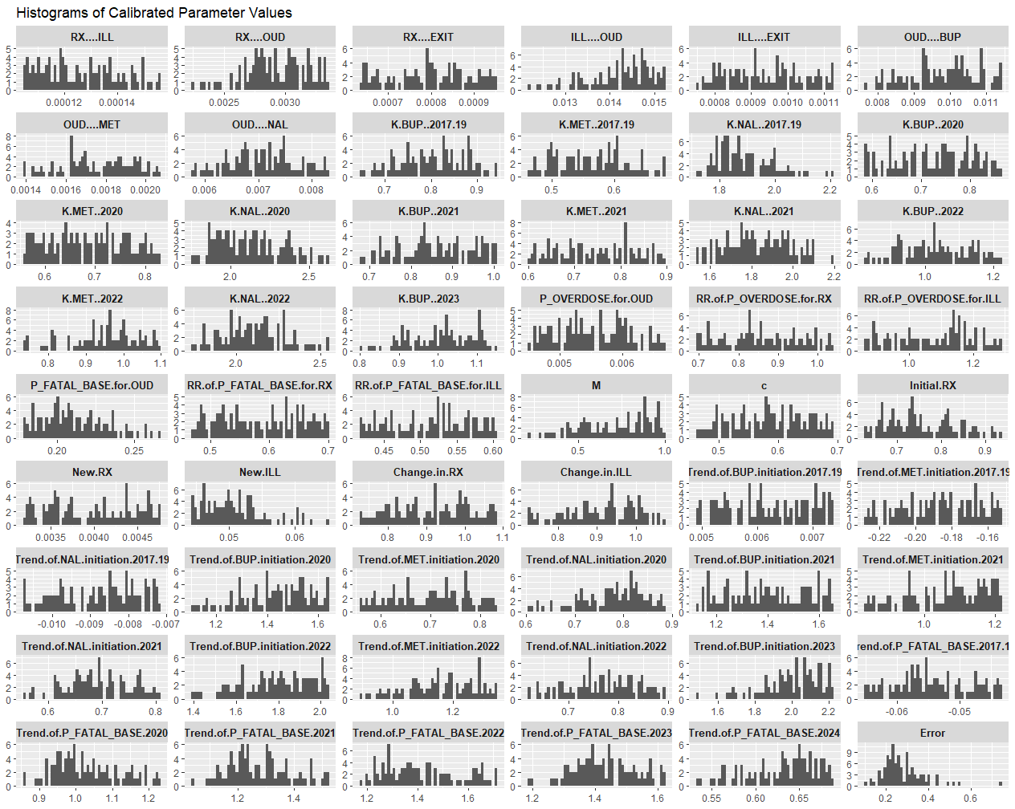 Supplementary Figure 3. Distribution of 100 replications of calibrated parameters for an example community.

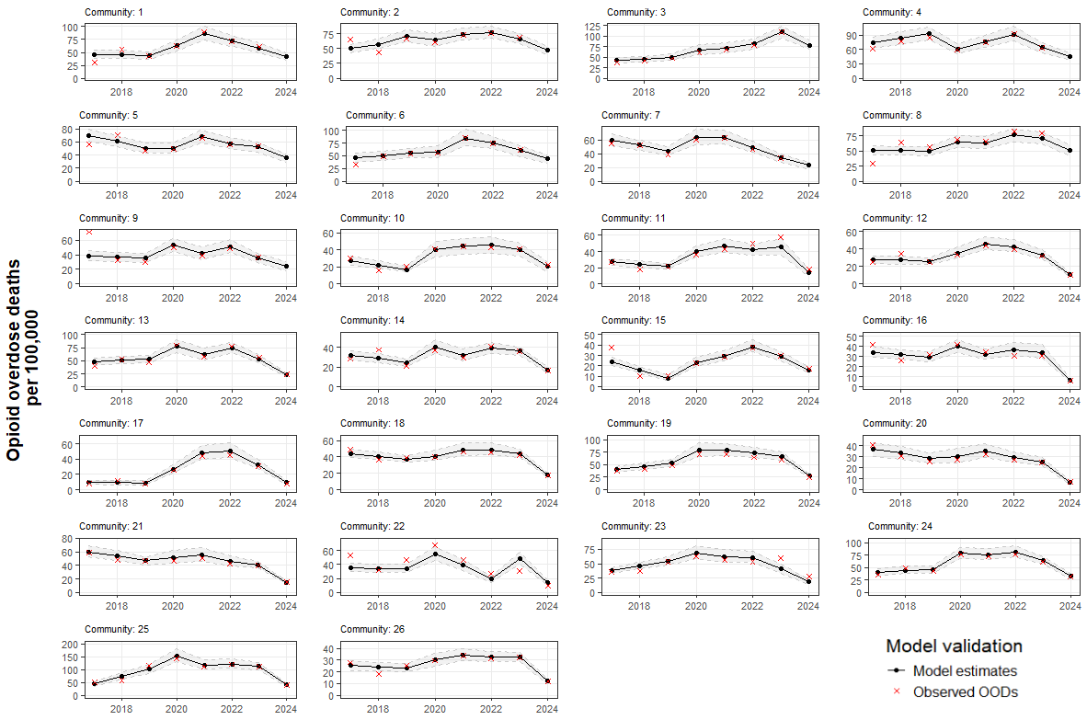
Supplementary Figure 4. Number of opioid overdose deaths per 100,000 population in each of the 26 simulated communities, 2017-2024.

S1.6. Model input tables
Supplementary Table 16. Key model parameter values.
Parameter | Base case value | Uncertainty range | References and notes
Age and sex distribution of initial population and new incidences
Initial population  Prescription, illicit, OUD | Sampled from empirical distribution |  | NSDUH^{9,12,13}  Supplement S2.2.3
New incidences to Prescription Opioid Use and Illicit Opioid Use states | Calibrated |  | Supplement S2.2.3
Monthly probability of state transitions
From Prescription Opioid Use to Illicit Opioid Use | Calibrated
From Prescription Opioid Use to OUD | Calibrated
From Illicit Opioid Use to OUD | Calibrated
From OUD to MOUD (treatment initiation) | Calibrated
MOUD discontinuation |  |  | Supplement S2.3.1
Baseline parametric function for treatment retention: $S\left(t\right)$ | Log-logistic $(λ=0.013, γ=0.986)$ | - | Morgan et al. (2018)¹⁹
Hazard ratio by the number of treatment episodes $n$: ${HR}_{n}^{d}$
$K_{med}$: medication-specific scalar | Calibrated
Episode 1 (n=1) | 1.0 | - | Nosyk et al. (2014)²⁰
Episode 2 (n=2) | 0.961 | [0.950, 0.989] | Nosyk et al. (2014)²⁰
Episode 3 (n=3) | 0.959 | [0.934, 0.985] | Nosyk et al. (2014)²⁰
Episode 4+ (n$≥$4) | 0.943 | [0.917, 0.970] | Nosyk et al. (2014)²⁰
Probability of recovery upon treatment discontinuation | 0.273 | - | Krebs et al. (2018)²¹
From Recovery to OUD (return to OUD) |  |  | Supplement S2.3.4
Survival function for time to return | Weibull $(λ=0.089, γ=0.797)$ | - | Nosyk et al. (2012)³⁵
Hazard ratio by the number of previous treatment episodes $n$: ${HR}_{n}^{r}$
Episode 0 (n=0) | 1.0 | - | Assumption
Episode 1 (n=1) | 1.0 | - | Nosyk et al. (2009)²⁶
Episode 2 (n=2) | 0.871 | [0.843, 0.901] | Nosyk et al. (2009)²⁶
Episode 3 (n=3) | 0.839 | [0.803, 0.878] | Nosyk et al. (2009)²⁶
Episode 4+ (n$≥$4) | 0.801 | [0.754, 0.850] | Nosyk et al. (2009)²⁶
From OUD to Recovery | 0.0056 |  | Fleury et al. (2016)²²
Overdose pathway parameters |  |  | Supplement S2.4.1
Baseline overdose probability | Calibrated
RR for prescription opioid use | Calibrated
RR for illicit opioid use | Calibrated
Probability of overdose being witnessed | 0.82 | [0.75, 0.88] | Zang et al. (2022)²⁷
Baseline probability the overdose being fatal for OUD state, $p_{fatal}^{base}$ | Calibrated
RR for MOUD: Month 1 | 0.297 (buprenorphine)  0.971 (methadone)  0.297 (naltrexone) |  | Santo et al. (2019)²⁸,  Sordo et al. (2017)³⁴
RR for MOUD: Month 2+ | 0.357 (buprenorphine)  0.437 (methadone)  0.357 (naltrexone) |  | Santo et al. (2019)²⁸,  Sordo et al. (2017)³⁴
RR of OUD in the first month after relapse
From discontinuing MOUD | 2.97 (buprenorphine)  1.04 (methadone)  2.97 (naltrexone) | - | Santo et al. (2021)²⁸, Sordo et al. (2017)³⁴
From Recovery | 2.97 | - | Assumption
RR for naloxone availability: $δ(t)$ |  |  | Supplement S2.4.2
Parameters $m$ and $c$ | Calibrated
Reporting probability of non-fatal overdose: $p_{reported}$ | 0.6 | - | Wampler et al. (2011)³⁶,  Karamouzian et al. (2019)³⁷
Other mortality parameters |  |  | Supplement S2.4.3
SMR of opioid-use population vs. general population | 5.02 | [4.21, 5.98] | Larney et al. (2020)³²
RR of opioid-use population vs. non-opioid-use population | 5.43 | [4.52, 6.52] | Larney et al. (2020)³²
Background mortality for general population | Age and sex specific |  | Arias et al. (2022)³³
HR: hazard ratio, MOUD: medications for opioid use disorder, OUD: opioid use disorder, SMR: standardized mortality ratio, RR: relative risk

Supplementary Table 17. Summary of calibrated parameters across 26 HCS communities.
Parameters | Mean | Min | Max
Transition probabilities (monthly)
From Prescription Opioid Use to Illicit Opioid Use | 0.00010 | 0.00008 | 0.00018
From Prescription Opioid Use to OUD | 0.00415 | 0.00286 | 0.00675
From Prescription Opioid Use to Exit | 0.00099 | 0.00077 | 0.00110
From Illicit Opioid Use to OUD | 0.01690 | 0.01082 | 0.03311
From Illicit Opioid Use to Exit | 0.00101 | 0.00086 | 0.00112
From OUD to MOUD (treatment initiation): Buprenorphine
Value up to 2017 | 0.01206 | 0.00529 | 0.01735
Percentage change in value for each year between 2017-19 | 12.0% | -6.6% | 109.1%
Value in 2020 | 0.01416 | 0.00511 | 0.02442
Value in 2021 | 0.01390 | 0.00529 | 0.02375
Value in 2022 | 0.01420 | 0.00425 | 0.02896
Value in 2023 | 0.01506 | 0.00411 | 0.03044
From OUD to MOUD (treatment initiation): Methadone
Value up to 2017 | 0.00414 | 0.00009 | 0.01264
Percentage change in value for each year between 2017-19 | 73.4% | -18.6% | 527.3%
Value in 2020 | 0.00561 | 0.00059 | 0.01268
Value in 2021 | 0.00612 | 0.00088 | 0.01786
Value in 2022 | 0.00610 | 0.00059 | 0.01572
From OUD to MOUD (treatment initiation): Naltrexone
Value up to 2017 | 0.00545 | 0.00195 | 0.01049
Percentage change in value for each year between 2017-19 | 0.9% | -19.6% | 60.6%
Value in 2020 | 0.00422 | 0.00184 | 0.00943
Value in 2021 | 0.00403 | 0.00141 | 0.01143
Value in 2022 | 0.00387 | 0.00144 | 0.01003
Treatment retention parameter $K_{med}$
Buprenorphine
Value up to 2019 | 0.84210 | 0.62685 | 1.12833
Value in 2020 | 0.82683 | 0.64213 | 1.36799
Value in 2021 | 0.86928 | 0.70534 | 1.08078
Value in 2022 | 0.91964 | 0.61274 | 1.36668
Value in 2023 | 1.27878 | 0.63204 | 2.36193
Methadone
Value up to 2019 | 0.78364 | 0.44559 | 1.39570
Value in 2020 | 0.67009 | 0.30555 | 1.05047
Value in 2021 | 0.76498 | 0.35262 | 1.78781
Value in 2022 | 0.86478 | 0.55716 | 2.17862
Naltrexone
Value up to 2019 | 2.01303 | 1.82731 | 2.31956
Value in 2020 | 2.11315 | 1.44951 | 2.64137
Value in 2021 | 1.97576 | 1.36598 | 2.91109
Value in 2022 | 2.06108 | 1.29609 | 2.62827
Initial population
Adjustment coefficient for initial population in Prescription Opioid Use | 0.82222 | 0.69875 | 0.97358
New incidences per month
Prescription Opioid Use | 58.77576 | 12.16358 | 334.62312
Illicit Opioid Use | 46.05925 | 7.22936 | 164.52906
Change in prescription opioid use after 2020 | 86.8% | 80.6% | 94.7%
Change in illicit opioid use after 2020 | 88.4% | 80.4% | 99.7%
Overdose pathway
Baseline overdose probability (in OUD and MOUD) | 0.00449 | 0.00154 | 0.00888
RR for Prescription Opioid Use (vs. OUD) | 0.61557 | 0.53513 | 0.85229
RR for Illicit Opioid Use (vs. OUD) | 1.04300 | 0.91245 | 1.17276
Baseline fatal probability of overdose (for OUD), $p_{fatal}^{base}$
Value up to 2017 | 0.15250 | 0.07633 | 0.28610
Percentage change in probability value for each year between 2017-19 | 0.3% | -32.5% | 77.7%
Value in 2020 | 0.20830 | 0.11027 | 0.42128
Value in 2021 | 0.22809 | 0.10267 | 0.45575
Value in 2022 | 0.23452 | 0.06908 | 0.51510
Value in 2023 | 0.21792 | 0.10927 | 0.36668
Value in 2024 | 0.10328 | 0.02745 | 0.20570
RR of fatal probability of overdose for
Prescription Opioid Use (vs. OUD) state | 0.55066 | 0.47240 | 0.63921
Illicit Opioid Use (vs. OUD) state | 0.55497 | 0.50089 | 0.63685
Naloxone availability: scaling parameter $m$ | 0.87635 | 0.49557 | 1.06034
Naloxone availability: saturation parameter $c$ | 0.52947 | 0.34906 | 0.81889
HCS, Healing Communities Study

S1.7. Probabilistic sensitivity analysis
We conducted probabilistic sensitivity analyses (PSA) to characterize uncertainty in model inputs and its impact on outcomes. The PSA followed standard approaches in health economic evaluation, in which parameter uncertainty is represented using prespecified probability distributions and propagated through repeated Monte Carlo simulation.
Probability distributions were assigned based on parameter type. Gamma distributions were used for cost parameters to reflect their non-negative and right-skewed nature, and beta distributions were used for probabilities and utility values to ensure values remained bounded between 0 and 1. These choices are consistent with established recommendations in the health economics literature³⁸.

Distribution parameters were derived from reported means and measures of variability (e.g., standard errors, confidence intervals, or ranges) when available.
For gamma distributions (e.g., costs), shape (k) and scale (θ) parameters were calculated from the mean and variance. For beta distributions (e.g., probabilities, utilities), shape parameters α and β were derived using method-of-moments approaches to match reported means and variances. When variability estimates were not directly available, standard assumptions informed by the literature were applied.
For each community and intervention scenario, model outcomes were evaluated across repeated Monte Carlo simulations, with parameter values sampled independently from their assigned distributions. For each simulation draw, total costs and QALYs were estimated, and incremental outcomes were calculated relative to the status quo.
Uncertainty in outcomes was summarized using 95% uncertainty intervals, defined as the 2.5th and 97.5th percentiles of the simulated distributions. Cost-effectiveness acceptability curves and expected loss (i.e., regret) were also estimated to quantify decision uncertainty across willingness-to-pay thresholds.

Supplement S2. Simulation scenarios
We simulated six different scenarios for the level of EBP implementation – a status quo scenario and five aspirational scenarios that involve scaling up of treatment initiation, treatment retention, and/or naloxone distribution. The scenarios are described below.

- Status quo. The levels of MOUD initiation and retention and naloxone distributed observed in 2024 in each community were maintained for the remaining period of the analysis (i.e., through 2030).
- Increase naloxone distribution in communities: We increased the number of naloxone kits distributed to a community each month starting from the year 2025 to achieve the goal that the total number of naloxone kits distributed during the year 2030 would equal the average size of the population with OUD during that year. We found that there were two communities in which naloxone distribution was already at a high level and did not need to increase further to achieve the 2030 goal. In these communities, we instead continued to simulate the monthly distribution of naloxone kits as distributed in 2024.
- Improve treatment retention rate at the clinical trial level: For each MOUD treatment, parameter $K_{med}$ was adjusted such that the resulting 6-month retention rate equaled 74% for methadone (with $K_{met}=0.6652$) and 46% for buprenorphine (with $K_{bup}=0.2693$).³⁹ Due to lack of retention data for naltrexone from clinical trials, we assumed the same retention rate as observed for buprenorphine (i.e. ${K_{nal}=K}_{bup}=0.2693$); given that naltrexone only constituted a relatively small portion of total MOUD use in all communities we simulated, we expected that this optimistic assumption would not significantly impact the main findings from the simulation projections.
- Increase treatment initiation (by expanding treatment outreach and/or capacity): We calculated the MOUD treatment rate as the proportion the population with OUD (i.e., individuals in either OUD or MOUD state) receiving MOUD in each month of 2030, and then the average of treatment rate in 2030 across 12 months. We increased the monthly treatment initiation probability for each type of MOUD (as of the calibrated value in 2024) by the same multiplier value such that the average treatment rate in 2030 reached 50%. This way, the overall treatment initiation rate was increased during the projection period, while maintaining the same distribution between MOUD treatment types.
- Combination of Scenarios 2 and 3 (i.e., increased treatment initiation and improved treatment retention).
- Combination of Scenarios 2, 3, and 5 (i.e., increased treatment initiation, improved treatment retention, and increased naloxone distribution).

Scenarios were defined based on number of individuals in need (i.e., the size of the OUD population in each community), and feasibility of reach. While ideally all individuals with OUD would be on MOUD, given that 2024 levels in the 26 communities were far from that goal, we simulated an aspirational, yet reachable, scenario of half of individuals with OUD initiating MOUD. Similarly, the scenario of increased retention was based on an aspirational level of retention as observed in clinical trials. Increasing naloxone distribution so the number of kits distributed annually was at least equal to the OUD population resulted in an increase in naloxone distribution of less than double the 2024 levels of distribution.

Supplement S3. Economic inputs
This section describes the costs and utility values used in the analysis. Our analysis from the healthcare perspective includes the costs of interventions (MOUD and naloxone) and the costs of utilization of healthcare (i.e., emergency medical services [EMS], outpatient, emergency department (ED), inpatient, and residential treatment services) that exceed utilization by the general population. The analysis from the societal perspective includes all costs included in the healthcare perspective, costs of lost productivity, and criminal justice costs. The outcome measure in our CEA is quality-adjusted life-years (QALYs) computed based on state-specific health utility values obtained through direct elicitation using a standard gamble method ⁴⁰. Costs were inflated to 2023 dollars using the medical-care specific consumer price index (CPI) for healthcare costs and the standard CPI for urban consumers for other costs. All costs and utilities were discounted at 3% annually.
Intervention costs
Costs of MOUD were computed for each of the three FDA-approved medications: methadone, buprenorphine, and naltrexone. The cost of methadone was obtained from the Medicare fee schedule. Opioid treatment programs (OTPs) were reimbursed to provide a bundle of services including both the cost of the methadone and non-drug costs such as counseling and drug testing ⁴¹. We converted this value to a monthly cost to match the cycle length of the model ($966 in 2023 dollars). The costs of buprenorphine and naloxone were obtained from the Federal Supply Schedule obtained in 2021 ⁴². Both buprenorphine and naltrexone are available in oral and injectable formulations, so the costs used in the model are averages of the costs of each formulation weighted by the proportion of days supplied of each formulation as recorded in the Medicaid claims data obtained for the HCS. During the 30-month study period (January 2020 – June 2022) across all 67 HCS communities, the proportion of days supplied represented by oral formulations was 97.7% for buprenorphine and 43.2% for naltrexone. Daily costs of oral medication were assumed to be $5.42 for buprenorphine (2021 dollars, assuming a daily dose of two 8mg/2mg buprenorphine/naloxone films) and $1.06 for naltrexone (2021 dollars, assuming a daily dose of 50mg). Monthly costs of injections in 2021 dollars were $1,115 and $958 for buprenorphine and naltrexone, respectively. Applying weights obtained from HCS data and inflating to 2023 dollars yielded monthly costs of $194 and $584 for buprenorphine and naltrexone, respectively. The appropriate monthly cost was applied to all individuals in the model who spent a month in the MOUD state receiving one of the three medications.
The cost of a naloxone kit was computed as the sum of the cost of naloxone itself ($45 in 2023 dollars) based on the over the counter price of Narcan nasal spray ⁴³ and the cost to distribute naloxone estimated at $37 per kit (2017 dollars). The distribution cost was obtained by applying national wage rates to a weighted average of setting-specific naloxone distribution costs in New York City provided by Behrends and colleagues ⁴⁴. The total cost of a distributed naloxone kit in 2023 US dollars was $88. This cost was applied to all naloxone kits distributed in the model.
Costs of healthcare utilization
We accounted for the costs of EMS (i.e., ambulance) responses to opioid overdoses and the costs of utilization of outpatient, ED, inpatient, and residential behavioral health (BH) services. The cost of an EMS response to an overdose was based on the average reimbursement for procedure code A0427 (Advanced Life Support, emergency, Level I) in rural areas across the areas representing the HCS communities in the 2021 Medicare Ambulance Fee Schedule ⁴⁵. The rural rate was used because it was considered most representative of HCS communities. The cost of an EMS response was $470 in 2023 dollars and was applied to all reported non-fatal overdoses in the model.
The costs of utilization of outpatient, ED, inpatient, and residential BH services were computed based on unit costs from various sources and Medicaid claims data gathered from HCS communities. The HCS study team obtained ten community-level measures of the count of healthcare interactions across outpatient (intensive BH, non-intensive BH and non-BH visits), ED (BH and non-BH visits), inpatient (detoxification, non-detoxification BH, and non-BH nights), and residential (detoxification and non-detoxification nights). Unit costs for outpatient visits were obtained from the Medicare Physician Fee Schedule ($81 and $97 for BH and non-BH, respectively in 2023 dollars); from McCollister and colleagues ⁴⁶ for intensive BH outpatient ($87 per visit), inpatient detoxification ($450 per night), and residential treatment ($185 per night); and from the Healthcare Utilization Project (HCUP) for ED visits ($578 for BH ; $485 for non-BH) and non-detoxification inpatient nights ($1,268 for BH; $3,137 for non-BH) ⁴⁷.
The community-level counts from the Medicaid claims data over the period from January 2020 – June 2022 were multiplied by the unit costs described above and categorized into outpatient, ED, inpatient, and residential services. To avoid double-counting bundled services provided to OTP patients, the total cost of methadone treatment in each community was subtracted from total outpatient costs. These community-specific sums represented the total cost of outpatient, ED, inpatient, and residential services provided to Medicaid beneficiaries in each of the 26 communities included in the model. We applied two adjustments to these values so that they would represent the total cost of these types of care for all individuals in the model. First, we extrapolated these values from Medicaid to the full population using the following formula:
${Cost_all}_{h,c}={Cost_mdcd}_{h, c}*(1+ \frac{{Pop_{all}}_{c}-{Pop_{mdcd}}_{c}}{{Pop_{mdcd}}_{c}}*{MedicaidRatio}_{h})$,
where ${Cost_mdcd}_{h, c}$ is the cost obtained by the product of the unit costs and counts for healthcare setting h and community c, ${Pop_{all}}_{c}$ and ${Pop_{mdcd}}_{c}$ represent the total and Medicaid beneficiary populations for community c, and ${MedicaidRatio}_{h}$ is the ratio of the utilization of services from healthcare setting h for an average non-Medicaid beneficiary compared to an average Medicaid beneficiary. The values for ${MedicaidRatio}_{h}$ were obtained from the National Survey on Drug Use and Health (NSDUH) public use files from 2018 and 2019 and were 0.799 for outpatient, 0.449 for ED, 0.487 for inpatient, and 0.185 for residential services. Second, we limited the scope of the community-level costs to represent only individuals represented by the model using the following formula:
${Cost_model}_{h,c}={Cost_all}_{h, c}*(1- \frac{{Pop_{all}}_{c}-{Pop_{model}}_{c}}{{Pop_{all}}_{c}}*{ModelRatio}_{h})$,
where ${Pop_{model}}_{c}$ is the number of people represented in the model obtained from output from the microsimulation and ${ModelRatio}_{s}$ is the ratio of the utilization of services from healthcare setting h for an average person represented by the model compared to an average person (regardless of whether they are represented by the model or not. The values from ${ModelRatio}_{h}$ were also obtained from the NSDUH public use files from 2018 and 2019. To obtain them, we defined a six-level variable in NSDUH to mirror as closely as possible the five mutually exclusive states in the microsimulation (with the remainder excluded from the model). We assigned NSDUH respondents to these levels sequentially as follows:
- IF past-year use of methadone or buprenorphine AND no past-month use of heroin or pain relievers, THEN RECOVERY WITH MOUD (MOUD), ELSE
- IF past-year OUD THEN OUD, ELSE
- IF past-year heroin use, THEN ILLICIT OPIOID USE (ILL), ELSE,
- IF past year non-medical pain reliever use, THEN PRESCRIPTION OPIOID MISUSE (RX), ELSE
- IF lifetime heroin or non-medical pain reliever use, THEN RECOVERY (REC), ELSE
- Out of model
Our healthcare setting-specific values of ${ModelRatio}_{h}$ represented the difference in utilization of each type of service for people assigned to the “out of model” condition compared to utilization for the full set of NSDUH respondents. These values were 0.980 for outpatient, 0.946 for ED, 0.920 for inpatient, and 0.429 for residential services.
Finally, we used our values of ${Cost_model}_{h,c}$ to identify model state-specific costs for each healthcare setting in each community, according to:
${Cost_model}_{h,c}=\sum_{s=1}^{5}{{(C}_{h,c,s}*N_{s})}$ ,
where $C_{h,c,s}$ is the monthly cost for utilization of services in healthcare setting h, in community c, for someone in model state s, and $N_{s}$ is the number of person-months in model state s in the microsimulation over the period from January 2020 – June 2022. We used simulated annealing ^{48,49} to identify values of $C_{h,c,s}$ that, when combined with $N_{s}$, were as close as possible to ${Cost_model}_{h,c}$. We applied constraints to this optimization procedure using the 95% confidence intervals of rates of healthcare utilization specific to healthcare setting h for people assigned to each of the five model states in NSDUH. We repeated the optimization process 200 times for each value of ${Cost_model}_{h,c}$ and took the average of the resulting values of $C_{h,c,s}$. These state-specific costs were made to represent the incremental costs associated with opioid misuse by subtracting costs representing utilization of services from healthcare setting h for individuals outside of the scope of the model (i.e., individuals with no history of OUD and no illicit opioid use or prescription opioid misuse). These were obtained by:
$\max{{(C}_{h,c,s}-\frac{{Cost_{all}}_{h,c}- {Cost_{model}}_{h,c}}{{Pop_{all}}_{c}-{Pop_{model}}_{c}}, 0})$.
Supplementary Table 18. Mean and range of healthcare costs and proportions of emergency (ED), inpatient (IP), outpatient (OP), and residential (RES) service use by health state.
Health state | Healthcare cost | ED | IP | OP | RES
RX | $ 14.5 [0.5, 64.9] | 0.36 [0, 0.73] | 0.02 [0, 0.25] | 0.33 [0, 0.66] | 0.29 [0.05, 1]
ILL | $ 70.5 [27.1, 186.2] | 0.67 [0.33, 0.91] | 0.14 [0, 0.48] | 0 [0, 0] | 0.19 [0.06, 0.4]
OUD | $ 342.1 [201.3, 597.8] | 0.13 [0.05, 0.25] | 0.63 [0.5, 0.79] | 0.14 [0.07, 0.25] | 0.1 [0.03, 0.15]
MOUD  (month 1) | $ 611.9 [371.4, 941] | 0.16 [0.06, 0.28] | 0.47 [0.29, 0.68] | 0.3 [0.18, 0.52] | 0.07 [0.02, 0.12]
MOUD  (month 1+) | $ 175.2 [103.4, 321.8] | 0.14 [0.05, 0.27] | 0.52 [0.33, 0.72] | 0.22 [0.12, 0.37] | 0.12 [0.03, 0.19]
REC | $ 7.4 [0.9, 28] | 0 [0, 0] | 0.02 [0, 0.41] | 0.57 [0, 0.91] | 0.41 [0.09, 1]

Productivity
Productivity was represented in the model using age- and sex-specific estimates from Grosse and colleagues ⁵⁰. The estimates represent the total value of both market and non-market activities. Market productivity comprises gross compensation from labor (i.e., wage/salary and benefits) and non-market productivity comprises activities such as caring for one’s household and dependents. Total monthly productivity (the sum of market and non-market productivity) from Grosse and colleagues ranges from $1,513 (females aged 75 and older) to $10,287 (males aged 45 to 54). We assumed that productivity for people under the age of 15 was $0.
To account for differences in productivity by model state, we updated an earlier effort to estimate productivity decrements using NSDUH data ⁵¹ to better reflect OUD (rather than SUD generally) and to use more recent data. We recoded the six-level NSDUH state variable defined in the Costs of Healthcare Utilization section into a four-level variable by combining the ILL and OUD states and the REC and “out of model” states. We regressed the count of hours worked in the past week on the four-level state variable, age group, sex, educational attainment, marital status, and an indicator for past-year alcohol use disorder. We computed the ratio of hours worked for the RX, ILL/OUD, and MOUD states to the remaining group as 0.937, 0.502, and 0.848, respectively. We computed age-, sex-, and model state-specific productivity costs as one minus the ratios computed times the age- and sex-specific productivity estimates from Grosse and colleagues ⁵⁰.
Criminal legal
Age-specific criminal legal costs were applied to individuals in the OUD state based on aggregate costs reported by Florence and colleagues ⁵² converted to age-specific per-person costs based on OUD case counts estimated by Murphy ⁵³. The criminal legal costs accounted for police protection, adjudication, incarceration, and property loss ⁵². The criminal legal costs represent costs attributable to opioid abuse or dependence and thus were applied only to the OUD state. Incremental criminal legal costs were assumed to be $0 for people in all other model states.
Supplementary Table 19. Age- and sex-specific productivity losses and criminal legal system costs.
Age Group | Productivity  (male) | Productivity  (female) | Criminal legal  (in OUD state)
Age 12 – 14 | 0 | 0 | $ 419
Age 15 – 24 | $ 2,006 | $ 2,268 | $ 320
Age 25 – 34 | $ 6,820 | $ 6,868 | $ 462
Age 35 – 44 | $ 10,206 | $ 8,218 | $ 643
Age 45 – 54 | $ 10,287 | $ 7,390 | $ 587
Age 55 – 64 | $ 8,341 | $ 6,126 | $ 539
Age 65 – 74 | $ 4,578 | $ 3,631 | $ 183
Age 75+ | $ 1,971 | $ 1,513 | $ 183

Health utility
Model state-specific health utility values were taken from a cross-sectional study that estimated participants’ preferences among seven states related to opioid use—active prescription misuse, active injection misuse, initiation methadone, stabilized methadone, initiation buprenorphine, stabilized buprenorphine, and remission— using a standard gamble method ⁴⁰. We applied active prescription misuse and active injection misuse to our RX and ILL states, respectively. To differentiate between misuse and OUD, we computed the ratio of SF-6D health utility for respondents with OUD compared to respondents engaging in opioid misuse from NESARC-3. We applied that ratio to a weighted average of the active prescription misuse and active injection misuse utilities. For MOUD, we applied the utility values representing initiation to the first month of an episode of MOUD and the values representing stabilized medication to subsequent months for methadone and buprenorphine, respectively. Utility values for both medications were lower during the initiation period. Because utilities specific to naltrexone were not available, we applied the initiation utility from methadone the lower of the two initiation utilities, to reflect challenges with naltrexone initiation; ⁵⁴ and the stabilized utility from buprenorphine (because naltrexone does not require regular visits to an OTP as methadone does). Finally, we applied the utility value for remission to the recovery state in the model. Utility values ranged from 0.482 (OUD) to 0.807 (REC).
Supplementary Table 20. Model parameter values.
Health state | Value
RX | 0.626
ILL | 0.512
OUD | 0.482
MOUD - Buprenorphine (month 1) | 0.710
MOUD - Buprenorphine (month 1+) | 0.774
MOUD - Methadone (month 1) | 0.617
MOUD - Methadone (month 1+) | 0.758
MOUD - Naltrexone (month 1) | 0.617
MOUD - Naltrexone (month 1+) | 0.774
REC | 0.807

Supplement S4. Supplementary results
Supplementary Table 21. All opioid-related deaths (Scenario 1) and changes (Scenarios 2-6) between 2025 and 2030.
Community | Maintain  2024 EBP Levels (Scenario 1) | Improved  Naloxone (Scenario 2) | Improved  Retention (Scenario 3) | Improved  Initiation (Scenario 4) | Improved  Initiation & Retention (Scenario 5) | Improved  All  (Scenario 6)
C1 | - | Nalo: 0% | Rete: 28% | Init: 184% | Init: 116%, Rete: 210% | Init: 116%, Rete: 210%, Nalo: 0%
C1 | 3,277 | 0 [0%] | -74 [-2%] | -327 [-10%] | -435 [-13%] | -435 [-13%]
C2 | - | Nalo: 23% | Rete: 229% | Init: 202% | Init: 29%, Rete: 511% | Init: 29%, Rete: 511%, Nalo: 23%
C2 | 1,861 | -10 [-1%] | -185 [-10%] | -212 [-11%] | -455 [-24%] | -461 [-25%]
C3 | - | Nalo: 165% | Rete: 139% | Init: 781% | Init: 365%, Rete: 1131% | Init: 365%, Rete: 1131%, Nalo: 165%
C3 | 2,677 | -48 [-2%] | -63 [-2%] | -359 [-13%] | -549 [-21%] | -588 [-22%]
C4 | - | Nalo: 49% | Rete: 38% | Init: 151% | Init: 73%, Rete: 182% | Init: 73%, Rete: 182%, Nalo: 49%
C4 | 2,442 | -29 [-1%] | -89 [-4%] | -213 [-9%] | -340 [-14%] | -363 [-15%]
C5 | - | Nalo: 0% | Rete: 55% | Init: 145% | Init: 41%, Rete: 186% | Init: 41%, Rete: 186%, Nalo: 0%
C5 | 2,343 | 0 [0%] | -127 [-5%] | -215 [-9%] | -377 [-16%] | -377 [-16%]
C6 | - | Nalo: 20% | Rete: 47% | Init: 149% | Init: 54%, Rete: 182% | Init: 54%, Rete: 182%, Nalo: 20%
C6 | 2,119 | -7 [0%] | -87 [-4%] | -188 [-9%] | -296 [-14%] | -303 [-14%]
C7 | - | Nalo: 0% | Rete: 44% | Init: 231% | Init: 133%, Rete: 280% | Init: 133%, Rete: 280%, Nalo: 0%
C7 | 1,765 | 0 [0%] | -48 [-3%] | -184 [-10%] | -265 [-15%] | -265 [-15%]
C8 | - | Nalo: 84% | Rete: 174% | Init: 298% | Init: 105%, Rete: 600% | Init: 105%, Rete: 600%, Nalo: 84%
C8 | 1,212 | -21 [-2%] | -66 [-5%] | -139 [-11%] | -252 [-21%] | -268 [-22%]
C9 | - | Nalo: 0% | Rete: 56% | Init: 228% | Init: 111%, Rete: 287% | Init: 111%, Rete: 287%, Nalo: 0%
C9 | 1,547 | -1 [0%] | -44 [-3%] | -151 [-10%] | -217 [-14%] | -216 [-14%]
C10 | - | Nalo: 84% | Rete: 31% | Init: 191% | Init: 131%, Rete: 233% | Init: 131%, Rete: 233%, Nalo: 84%
C10 | 988 | -9 [-1%] | -21 [-2%] | -113 [-11%] | -148 [-15%] | -155 [-16%]
C11 | - | Nalo: 19% | Rete: 65% | Init: 274% | Init: 133%, Rete: 349% | Init: 134%, Rete: 349%, Nalo: 19%
C11 | 1,212 | -4 [0%] | -37 [-3%] | -117 [-10%] | -183 [-15%] | -185 [-15%]
C12 | - | Nalo: 0% | Rete: 54% | Init: 173% | Init: 72%, Rete: 223% | Init: 72%, Rete: 223%, Nalo: 0%
C12 | 1,280 | 0 [0%] | -47 [-4%] | -109 [-9%] | -172 [-13%] | -172 [-13%]
C13 | - | Nalo: 60% | Rete: 143% | Init: 188% | Init: 33%, Rete: 355% | Init: 33%, Rete: 355%, Nalo: 60%
C13 | 727 | -13 [-2%] | -49 [-7%] | -73 [-10%] | -134 [-18%] | -144 [-20%]
C14 | - | Nalo: 0% | Rete: 64% | Init: 238% | Init: 125%, Rete: 327% | Init: 125%, Rete: 327%, Nalo: 0%
C14 | 791 | 0 [0%] | -25 [-3%] | -85 [-11%] | -127 [-16%] | -127 [-16%]
C15 | - | Nalo: 6% | Rete: 61% | Init: 209% | Init: 110%, Rete: 292% | Init: 110%, Rete: 292%, Nalo: 6%
C15 | 673 | 0 [0%] | -18 [-3%] | -67 [-10%] | -95 [-14%] | -95 [-14%]
C16 | - | Nalo: 114% | Rete: 41% | Init: 76% | Init: 26%, Rete: 118% | Init: 26%, Rete: 118%, Nalo: 114%
C16 | 577 | -17 [-3%] | -18 [-3%] | -35 [-6%] | -55 [-10%] | -69 [-12%]
C17 | - | Nalo: 0% | Rete: 135% | Init: 141% | Init: 30%, Rete: 315% | Init: 30%, Rete: 315%, Nalo: 0%
C17 | 554 | 0 [0%] | -34 [-6%] | -50 [-9%] | -92 [-17%] | -92 [-17%]
C18 | - | Nalo: 60% | Rete: 69% | Init: 319% | Init: 186%, Rete: 440% | Init: 186%, Rete: 440%, Nalo: 60%
C18 | 575 | -5 [-1%] | -11 [-2%] | -58 [-10%] | -79 [-14%] | -83 [-14%]
C19 | - | Nalo: 38% | Rete: 68% | Init: 283% | Init: 143%, Rete: 372% | Init: 142%, Rete: 372%, Nalo: 38%
C19 | 499 | -6 [-1%] | -12 [-2%] | -46 [-9%] | -67 [-13%] | -72 [-14%]
C20 | - | Nalo: 162% | Rete: 122% | Init: 194% | Init: 50%, Rete: 344% | Init: 50%, Rete: 344%, Nalo: 162%
C20 | 552 | -17 [-3%] | -34 [-6%] | -57 [-10%] | -101 [-18%] | -114 [-21%]
C21 | - | Nalo: 0% | Rete: 84% | Init: 377% | Init: 216%, Rete: 546% | Init: 216%, Rete: 546%, Nalo: 0%
C21 | 495 | 0 [0%] | -9 [-2%] | -50 [-10%] | -71 [-14%] | -71 [-14%]
C22 | - | Nalo: 0% | Rete: 170% | Init: 226% | Init: 63%, Rete: 478% | Init: 63%, Rete: 478%, Nalo: 0%
C22 | 476 | 0 [0%] | -29 [-6%] | -46 [-10%] | -89 [-19%] | -89 [-19%]
C23 | - | Nalo: 0% | Rete: 226% | Init: 435% | Init: 150%, Rete: 892% | Init: 150%, Rete: 892%, Nalo: 0%
C23 | 399 | 0 [0%] | -17 [-4%] | -47 [-12%] | -81 [-20%] | -81 [-20%]
C24 | - | Nalo: 35% | Rete: 86% | Init: 149% | Init: 46%, Rete: 250% | Init: 46%, Rete: 250%, Nalo: 35%
C24 | 455 | -6 [-1%] | -23 [-5%] | -37 [-8%] | -68 [-15%] | -73 [-16%]
C25 | - | Nalo: 14% | Rete: 259% | Init: 555% | Init: 217%, Rete: 1234% | Init: 217%, Rete: 1234%, Nalo: 14%
C25 | 390 | -2 [-1%] | -13 [-3%] | -41 [-11%] | -73 [-19%] | -74 [-19%]
C26 | - | Nalo: 0% | Rete: 62% | Init: 184% | Init: 92%, Rete: 265% | Init: 92%, Rete: 265%, Nalo: 0%
C26 | 347 | 0 [0%] | -8 [-2%] | -22 [-6%] | -34 [-10%] | -34 [-10%]
Abbreviations: C = Community, EBP = Evidence-Based Practice; Init = Improved Initiation; Nalo = Improved Naloxone Distribution; Rete = Improved Retention.
Percentages in brackets represent the relative change compared to the "Maintain 2024 EBP Levels" scenario. Negative percentages indicate a reduction in deaths, while positive percentages indicate an increase.

Supplementary Table 22. Total (Scenario 1) and incremental (Scenarios 2-6) healthcare costs (million US$) associated with opioid misuse between 2025 and 2030.
Community | Maintain  2024 EBP Levels (Scenario 1) | Improved  Naloxone (Scenario 2) | Improved  Retention (Scenario 3) | Improved  Initiation (Scenario 4) | Improved  Initiation & Retention (Scenario 5) | Improved  All  (Scenario 6)
C1 | - | Nalo: 0% | Rete: 28% | Init: 184% | Init: 116%, Rete: 210% | Init: 116%, Rete: 210%, Nalo: 0%
C1 | 146 | +0 [0%] | +21 [14%] | +44 [30%] | +82 [56%] | +82 [56%]
C2 | - | Nalo: 23% | Rete: 229% | Init: 202% | Init: 29%, Rete: 511% | Init: 29%, Rete: 511%, Nalo: 23%
C2 | 197 | +1 [0%] | +36 [18%] | +64 [33%] | +95 [48%] | +96 [49%]
C3 | - | Nalo: 165% | Rete: 139% | Init: 781% | Init: 365%, Rete: 1131% | Init: 365%, Rete: 1131%, Nalo: 165%
C3 | 137 | +2 [2%] | +24 [17%] | +85 [62%] | +171 [125%] | +173 [127%]
C4 | - | Nalo: 49% | Rete: 38% | Init: 151% | Init: 73%, Rete: 182% | Init: 73%, Rete: 182%, Nalo: 49%
C4 | 159 | +0 [0%] | +25 [15%] | +26 [16%] | +67 [42%] | +67 [42%]
C5 | - | Nalo: 0% | Rete: 55% | Init: 145% | Init: 41%, Rete: 186% | Init: 41%, Rete: 186%, Nalo: 0%
C5 | 111 | +0 [0%] | +27 [24%] | +21 [19%] | +62 [56%] | +62 [56%]
C6 | - | Nalo: 20% | Rete: 47% | Init: 149% | Init: 54%, Rete: 182% | Init: 54%, Rete: 182%, Nalo: 20%
C6 | 429 | +1 [0%] | +81 [19%] | +87 [20%] | +210 [49%] | +212 [49%]
C7 | - | Nalo: 0% | Rete: 44% | Init: 231% | Init: 133%, Rete: 280% | Init: 133%, Rete: 280%, Nalo: 0%
C7 | 106 | +0 [0%] | +15 [14%] | +23 [22%] | +56 [53%] | +56 [53%]
C8 | - | Nalo: 84% | Rete: 174% | Init: 298% | Init: 105%, Rete: 600% | Init: 105%, Rete: 600%, Nalo: 84%
C8 | 114 | +1 [1%] | +15 [13%] | +38 [33%] | +56 [49%] | +57 [50%]
C9 | - | Nalo: 0% | Rete: 56% | Init: 228% | Init: 111%, Rete: 287% | Init: 111%, Rete: 287%, Nalo: 0%
C9 | 186 | +0 [0%] | +33 [17%] | +58 [31%] | +117 [63%] | +117 [63%]
C10 | - | Nalo: 84% | Rete: 31% | Init: 191% | Init: 131%, Rete: 233% | Init: 131%, Rete: 233%, Nalo: 84%
C10 | 87 | +1 [1%] | +7 [8%] | +10 [12%] | +25 [29%] | +26 [29%]
C11 | - | Nalo: 19% | Rete: 65% | Init: 274% | Init: 133%, Rete: 349% | Init: 134%, Rete: 349%, Nalo: 19%
C11 | 62 | +0 [0%] | +11 [18%] | +15 [24%] | +40 [64%] | +40 [64%]
C12 | - | Nalo: 0% | Rete: 54% | Init: 173% | Init: 72%, Rete: 223% | Init: 72%, Rete: 223%, Nalo: 0%
C12 | 127 | +1 [1%] | +30 [24%] | +31 [25%] | +84 [66%] | +84 [67%]
C13 | - | Nalo: 60% | Rete: 143% | Init: 188% | Init: 33%, Rete: 355% | Init: 33%, Rete: 355%, Nalo: 60%
C13 | 87 | +1 [1%] | +25 [29%] | +30 [35%] | +62 [71%] | +63 [72%]
C14 | - | Nalo: 0% | Rete: 64% | Init: 238% | Init: 125%, Rete: 327% | Init: 125%, Rete: 327%, Nalo: 0%
C14 | 1,654 | +0 [0%] | +131 [8%] | +191 [12%] | +451 [27%] | +451 [27%]
C15 | - | Nalo: 6% | Rete: 61% | Init: 209% | Init: 110%, Rete: 292% | Init: 110%, Rete: 292%, Nalo: 6%
C15 | 573 | +0 [0%] | +35 [6%] | +61 [11%] | +120 [21%] | +121 [21%]
C16 | - | Nalo: 114% | Rete: 41% | Init: 76% | Init: 26%, Rete: 118% | Init: 26%, Rete: 118%, Nalo: 114%
C16 | 56 | +1 [1%] | +5 [10%] | +4 [8%] | +11 [20%] | +12 [21%]
C17 | - | Nalo: 0% | Rete: 135% | Init: 141% | Init: 30%, Rete: 315% | Init: 30%, Rete: 315%, Nalo: 0%
C17 | 122 | +0 [0%] | +17 [14%] | +34 [28%] | +48 [39%] | +48 [39%]
C18 | - | Nalo: 60% | Rete: 69% | Init: 319% | Init: 186%, Rete: 440% | Init: 186%, Rete: 440%, Nalo: 60%
C18 | 98 | +1 [1%] | +4 [4%] | +6 [6%] | +16 [16%] | +16 [17%]
C19 | - | Nalo: 38% | Rete: 68% | Init: 283% | Init: 143%, Rete: 372% | Init: 142%, Rete: 372%, Nalo: 38%
C19 | 924 | +4 [0%] | +91 [10%] | +139 [15%] | +334 [36%] | +339 [37%]
C20 | - | Nalo: 162% | Rete: 122% | Init: 194% | Init: 50%, Rete: 344% | Init: 50%, Rete: 344%, Nalo: 162%
C20 | 140 | +2 [1%] | +30 [22%] | +39 [28%] | +80 [57%] | +82 [59%]
C21 | - | Nalo: 0% | Rete: 84% | Init: 377% | Init: 216%, Rete: 546% | Init: 216%, Rete: 546%, Nalo: 0%
C21 | 155 | +0 [0%] | +8 [5%] | +17 [11%] | +40 [26%] | +40 [26%]
C22 | - | Nalo: 0% | Rete: 170% | Init: 226% | Init: 63%, Rete: 478% | Init: 63%, Rete: 478%, Nalo: 0%
C22 | 144 | +0 [0%] | +15 [11%] | +36 [25%] | +49 [34%] | +49 [34%]
C23 | - | Nalo: 0% | Rete: 226% | Init: 435% | Init: 150%, Rete: 892% | Init: 150%, Rete: 892%, Nalo: 0%
C23 | 241 | +0 [0%] | +36 [15%] | +106 [44%] | +159 [66%] | +159 [66%]
C24 | - | Nalo: 35% | Rete: 86% | Init: 149% | Init: 46%, Rete: 250% | Init: 46%, Rete: 250%, Nalo: 35%
C24 | 106 | +0 [0%] | +9 [8%] | +6 [6%] | +20 [18%] | +20 [19%]
C25 | - | Nalo: 14% | Rete: 259% | Init: 555% | Init: 217%, Rete: 1234% | Init: 217%, Rete: 1234%, Nalo: 14%
C25 | 312 | +1 [0%] | +13 [4%] | +72 [23%] | +81 [26%] | +82 [26%]
C26 | - | Nalo: 0% | Rete: 62% | Init: 184% | Init: 92%, Rete: 265% | Init: 92%, Rete: 265%, Nalo: 0%
C26 | 1,177 | +0 [0%] | +42 [4%] | +21 [2%] | +100 [8%] | +100 [8%]
Abbreviations: C = Community, EBP = Evidence-Based Practice; Init = Improved Initiation; Nalo = Improved Naloxone Distribution; Rete = Improved Retention.
Percentages in brackets represent the relative change compared to the "Maintain 2022 EBP Levels" scenario. Negative percentages indicate a reduction in cost, while positive percentages indicate an increase.
Supplementary Table 23. Net benefits (million US$) at willingness-to-pay threshold $100,000.
Community | Maintain  2024 EBP Levels (Scenario 1) | Improved  Naloxone (Scenario 2) | Improved  Retention (Scenario 3) | Improved  Initiation  (Scenario 4) | Improved  Initiation & Retention (Scenario 5) | Improved  All  (Scenario 6)
C1* | 4,331 | 4,331 | 4,365 | 4,514 | 4,562 | 4,562
C2 | 6,029 | 6,030 | 6,309 | 6,257 | 6,682 | 6,682
C3 | 6,242 | 6,244 | 6,310 | 6,599 | 6,828 | 6,831
C4 | 3,932 | 3,932 | 3,994 | 4,086 | 4,171 | 4,171
C5* | 2,623 | 2,623 | 2,674 | 2,722 | 2,784 | 2,784
C6 | 9,744 | 9,745 | 9,904 | 10,106 | 10,309 | 10,309
C7* | 3,277 | 3,277 | 3,308 | 3,428 | 3,479 | 3,479
C8 | 4,125 | 4,126 | 4,238 | 4,302 | 4,518 | 4,519
C9* | 5,950 | 5,950 | 6,025 | 6,187 | 6,309 | 6,309
C10 | 3,129 | 3,129 | 3,155 | 3,272 | 3,311 | 3,311
C11 | 1,946 | 1,947 | 1,970 | 2,035 | 2,074 | 2,074
C12* | 3,791 | 3,791 | 3,829 | 3,936 | 3,982 | *
C13 | 3,268 | 3,269 | 3,365 | 3,369 | 3,509 | 3,509
C14* | 45,212 | 45,212 | 45,902 | 47,408 | 48,590 | 48,590
C15 | 15,008 | 15,008 | 15,240 | 15,671 | 16,056 | 16,056
C16 | 1,771 | 1,771 | 1,804 | 1,819 | 1,859 | 1,859
C17* | 4,147 | 4,147 | 4,267 | 4,251 | 4,425 | 4,425
C18 | 2,927 | 2,927 | 2,965 | 3,085 | 3,164 | 3,164
C19 | 23,057 | 23,058 | 23,370 | 24,169 | 24,726 | 24,728
C20 | 5,735 | 5,737 | 5,882 | 5,928 | 6,146 | 6,148
C21* | 4,610 | 4,610 | 4,665 | 4,850 | 4,978 | 4,978
C22* | 4,664 | 4,664 | 4,803 | 4,830 | 5,059 | 5,059
C23* | 8,487 | 8,487 | 8,667 | 8,795 | 9,221 | 9,221
C24 | 2,417 | 2,417 | 2,475 | 2,505 | 2,584 | 2,584
C25 | 7,497 | 7,497 | 7,650 | 7,824 | 8,256 | 8,256
C26* | 24,918 | 24,918 | 25,285 | 25,874 | 26,430 | 26,430
Abbreviations: C = Community, EBP = Evidence-Based Practice.
* Naloxone improvement scenarios were excluded as communities have already implemented enhanced naloxone distribution. Therefore, Scenarios 1 & 2, and Scenarios 5 & 6 are equivalent.

Supplementary Table 24. Distribution of healthcare costs (million US$, 2025-2030) Scenario 1 (“Maintain 2024 EBP Levels”) associated with opioid misuse in each community.
Community | Maintain 2024 EBP Levels (Scenario 1)
Community | EMS | Health state  (ED) | Health state  (IP) | Health state  (OP) | Health state  (RES) | MOUD | Naloxone | Total
C1 | 6.6 | 304.3 | 692.3 | 143.9 | 73.0 | 111.9 | 23.1 | 1355.2
C2 | 1.4 | 69.8 | 176.4 | 50.3 | 22.5 | 33.3 | 4.0 | 357.7
C3 | 1.1 | 11.6 | 142.7 | 32.4 | 19.1 | 55.5 | 14.8 | 277.3
C4 | 0.4 | 27.8 | 55.1 | 16.5 | 7.2 | 14.6 | 1.1 | 122.7
C5 | 0.8 | 9.4 | 92.6 | 12.9 | 9.8 | 36.7 | 4.0 | 166.1
C6 | 6.4 | 199.5 | 527.1 | 121.1 | 49.0 | 155.7 | 11.0 | 1069.9
C7 | 0.8 | 39.8 | 81.4 | 25.5 | 13.1 | 14.5 | 3.4 | 178.6
C8 | 0.8 | 8.2 | 75.7 | 17.0 | 14.1 | 43.7 | 1.2 | 160.7
C9 | 0.7 | 22.7 | 48.2 | 16.2 | 15.5 | 8.8 | 1.1 | 113.2
C10 | 0.5 | 8.0 | 55.6 | 7.9 | 11.3 | 55.8 | 2.8 | 141.8
C11 | 0.3 | 13.4 | 23.2 | 7.9 | 2.5 | 16.5 | 0.5 | 64.4
C12 | 3.5 | 124.6 | 300.4 | 65.4 | 41.3 | 116.1 | 9.0 | 660.5
C13 | 9.2 | 329.0 | 934.0 | 208.9 | 110.1 | 271.1 | 40.6 | 1903.0
C14 | 1.5 | 21.3 | 84.3 | 13.9 | 15.0 | 42.0 | 4.9 | 183.0
C15 | 0.4 | 4.4 | 43.8 | 9.9 | 9.2 | 31.3 | 1.2 | 100.2
C16 | 0.3 | 7.8 | 33.7 | 7.3 | 6.9 | 14.4 | 1.0 | 71.4
C17 | 1.3 | 21.5 | 76.7 | 24.4 | 20.7 | 66.4 | 3.6 | 214.7
C18 | 0.2 | 17.7 | 43.5 | 14.6 | 4.8 | 17.8 | 1.0 | 99.7
C19 | 0.6 | 10.1 | 55.4 | 11.9 | 15.0 | 27.2 | 2.2 | 122.2
C20 | 2.4 | 49.4 | 174.2 | 58.7 | 55.4 | 151.6 | 5.7 | 497.4
C21 | 0.7 | 18.3 | 48.3 | 22.2 | 11.3 | 28.2 | 1.4 | 130.4
C22 | 0.8 | 13.6 | 43.5 | 16.4 | 14.7 | 37.3 | 1.8 | 128.1
C23 | 1.0 | 24.7 | 76.0 | 22.2 | 8.7 | 23.7 | 1.6 | 157.9
C24 | 0.5 | 12.0 | 50.8 | 14.7 | 16.0 | 50.5 | 1.7 | 146.3
C25 | 0.8 | 20.4 | 77.4 | 45.0 | 22.6 | 56.4 | 3.3 | 226.0
C26 | 0.6 | 15.2 | 45.2 | 23.8 | 16.4 | 63.1 | 4.7 | 169.1
Abbreviations: C = Community; EBP = Evidence-Based Practice; ED = Emergency Department; EMS = Emergency Medical Services; IP = Inpatient; MOUD: Medications for Opioid Use Disorder; OP = Outpatient; RES = Residential Services.

Supplementary Table 25. Distribution of healthcare costs (million US$, 2025-2030) Scenario 6 (“Improve All”) associated with opioid misuse in each community.
Community | Improve All (Scenario 6)
Community | EMS | Health state  (ED) | Health state  (IP) | Health state  (OP) | Health state  (RES) | MOUD | Naloxone | Total
C1 | 6.6 | 274.6 | 543.4 | 141.4 | 62.8 | 425.9 | 23.1 | 1477.8
C2 | 1.4 | 59.7 | 121.3 | 49.9 | 18.0 | 200.8 | 4.6 | 455.8
C3 | 1.1 | 10.0 | 98.4 | 31.7 | 15.3 | 297.4 | 14.8 | 468.7
C4 | 0.4 | 24.1 | 40.9 | 15.8 | 6.0 | 58.7 | 1.4 | 147.3
C5 | 0.8 | 8.0 | 66.5 | 12.6 | 8.1 | 126.1 | 4.0 | 225.9
C6 | 6.4 | 176.1 | 378.0 | 117.9 | 41.0 | 750.9 | 15.2 | 1485.6
C7 | 0.8 | 34.7 | 59.6 | 25.6 | 10.9 | 91.8 | 3.4 | 226.7
C8 | 0.8 | 7.0 | 52.8 | 16.7 | 11.6 | 168.3 | 3.2 | 260.4
C9 | 0.7 | 19.0 | 33.2 | 15.6 | 12.9 | 49.7 | 1.8 | 132.8
C10 | 0.5 | 6.8 | 41.5 | 7.7 | 9.6 | 131.0 | 2.8 | 199.9
C11 | 0.3 | 12.1 | 18.9 | 7.7 | 2.2 | 36.6 | 1.1 | 78.8
C12 | 3.5 | 107.2 | 218.7 | 63.3 | 35.0 | 370.4 | 9.5 | 807.7
C13 | 9.2 | 280.1 | 684.3 | 203.5 | 92.2 | 1143.9 | 40.6 | 2453.8
C14 | 1.5 | 18.5 | 64.4 | 13.9 | 13.0 | 149.0 | 4.9 | 265.3
C15 | 0.4 | 3.5 | 30.0 | 9.4 | 7.5 | 123.4 | 1.9 | 176.2
C16 | 0.3 | 6.8 | 24.1 | 7.3 | 5.9 | 74.3 | 1.2 | 120.0
C17 | 1.4 | 18.4 | 55.8 | 24.3 | 17.8 | 236.0 | 3.6 | 357.2
C18 | 0.2 | 15.6 | 33.1 | 14.8 | 4.2 | 61.0 | 1.9 | 130.7
C19 | 0.6 | 8.8 | 41.1 | 12.1 | 13.0 | 113.1 | 2.2 | 190.8
C20 | 2.4 | 43.2 | 126.8 | 59.8 | 48.4 | 471.2 | 6.8 | 758.7
C21 | 0.6 | 14.4 | 31.2 | 21.9 | 9.1 | 118.1 | 2.6 | 198.1
C22 | 0.8 | 11.5 | 31.1 | 16.0 | 12.7 | 130.3 | 1.8 | 204.1
C23 | 1.0 | 18.6 | 47.7 | 21.6 | 6.9 | 267.5 | 4.1 | 367.5
C24 | 0.6 | 10.4 | 37.8 | 15.1 | 14.1 | 169.5 | 2.5 | 250.0
C25 | 0.8 | 13.2 | 40.5 | 35.4 | 16.7 | 230.0 | 4.1 | 340.7
C26 | 0.6 | 13.3 | 34.1 | 24.8 | 14.4 | 177.4 | 4.7 | 269.4
Abbreviations: C = Community; ED = Emergency Department; EMS = Emergency Medical Services; IP = Inpatient; MOUD: Medications for Opioid Use Disorder; OP = Outpatient; RES = Residential Services.

Supplementary Table 26. Total (Scenario 1) and incremental (Scenarios 2-6) societal costs (million US$) associated with opioid misuse between 2025 and 2030.
Community | Maintain  2024 EBP Levels (Scenario 1) | Improved  Naloxone  (Scenario 2) | Improved  Retention (Scenario 3) | Improved  Initiation  (Scenario 4) | Improved  Initiation & Retention  (Scenario 5) | Improved  All  (Scenario 6)
C1* | 9,780 | 0 | -1,407 | -507 | -2,103 | -2,103
C2 | 3,354 | -1 | -523 | -216 | -1,059 | -1,059
C3 | 3,356 | 0 | -505 | -254 | -1,025 | -1,025
C4 | 971 | 0 | -131 | -79 | -228 | -229
C5* | 1,823 | 0 | -254 | -187 | -533 | -533
C6 | 10,021 | -2 | -1,693 | -452 | -2,389 | -2,392
C7* | 1,939 | 0 | -359 | -79 | -519 | -519
C8 | 2,078 | -2 | -297 | -200 | -560 | -563
C9* | 1,263 | 0 | -233 | -53 | -330 | -330
C10 | 1,522 | 0 | -163 | -161 | -376 | -376
C11 | 655 | -1 | -71 | -44 | -120 | -121
C12* | 6,164 | 0 | -986 | -320 | -1,462 | -1,462
C13 | 19,174 | 0 | -3,264 | -966 | -4,735 | -4,735
C14* | 2,091 | 0 | -256 | -97 | -375 | -375
C15 | 1,215 | -1 | -162 | -133 | -330 | -331
C16 | 1,032 | 0 | -148 | -38 | -204 | -204
C17* | 3,143 | 0 | -406 | -121 | -577 | -577
C18 | 1,257 | -0 | -206 | -36 | -257 | -257
C19 | 1,769 | 0 | -248 | -52 | -322 | -322
C20 | 5,694 | -1 | -622 | -256 | -910 | -911
C21* | 1,769 | 0 | -277 | -156 | -544 | -544
C22* | 1,498 | 0 | -167 | -81 | -256 | -256
C23* | 3,678 | 0 | -625 | -111 | -942 | -942
C24 | 2,077 | -1 | -243 | -66 | -316 | -318
C25 | 2,690 | 0 | -369 | -382 | -889 | -889
C26* | 2,504 | 0 | -307 | -56 | -379 | -379
Abbreviations: C = Community, EBP = Evidence-Based Practice.
* Naloxone improvement scenarios were excluded as communities have already implemented enhanced naloxone distribution. Therefore, Scenarios 1 & 2, and Scenarios 5 & 6 are equivalent.

Supplementary Table 27. Distribution of societal costs (million US$, 2025-2030) in Scenario 1 (“Maintain 2024 EBP Levels”) associated with opioid misuse in each community.
Community | Maintain 2024 EBP Levels (Scenario 1)
Community | Total Healthcare  Costs | Overdose | Criminal | Production Cost | Total
C1 | 1,355 | 19 | 679 | 7,727 | 9,780
C2 | 358 | 4 | 277 | 2,715 | 3,354
C3 | 277 | 3 | 291 | 2,785 | 3,356
C4 | 123 | 1 | 72 | 775 | 971
C5 | 166 | 2 | 149 | 1,506 | 1,823
C6 | 1,070 | 18 | 795 | 8,139 | 10,021
C7 | 179 | 2 | 160 | 1,598 | 1,939
C8 | 161 | 2 | 170 | 1,745 | 2,078
C9 | 113 | 2 | 101 | 1,047 | 1,263
C10 | 142 | 1 | 119 | 1,259 | 1,522
C11 | 64 | 1 | 49 | 541 | 655
C12 | 660 | 10 | 486 | 5,007 | 6,164
C13 | 1,903 | 26 | 1,533 | 15,712 | 19,174
C14 | 183 | 4 | 127 | 1,777 | 2,091
C15 | 100 | 1 | 102 | 1,012 | 1,215
C16 | 71 | 1 | 67 | 892 | 1,032
C17 | 215 | 4 | 197 | 2,727 | 3,143
C18 | 100 | 1 | 95 | 1,062 | 1,257
C19 | 122 | 2 | 111 | 1,534 | 1,769
C20 | 497 | 7 | 326 | 4,864 | 5,694
C21 | 130 | 2 | 152 | 1,485 | 1,769
C22 | 128 | 2 | 88 | 1,279 | 1,498
C23 | 158 | 3 | 264 | 3,253 | 3,678
C24 | 146 | 2 | 123 | 1,806 | 2,077
C25 | 226 | 2 | 234 | 2,228 | 2,690
C26 | 169 | 2 | 145 | 2,188 | 2,504
Abbreviations: C = Community; EBP = Evidence-Based Practice.
Communities are in order of decreasing OUD prevalence in the “Maintain 2024 EBP Levels” scenario.

Supplementary Table 28. Distribution of societal costs (million US$, 2025-2030) in Scenario 6 (“Improve All”) associated with opioid misuse in each community.
Community | Improve All (Scenario 6)
Community | Total Healthcare  Costs | Overdose | Criminal | Production Cost | Total
C1 | 1,478 | 19 | 301 | 5,879 | 7,677
C2 | 456 | 4 | 84 | 1,752 | 2,295
C3 | 469 | 3 | 86 | 1,774 | 2,332
C4 | 147 | 1 | 29 | 565 | 742
C5 | 226 | 2 | 50 | 1,012 | 1,290
C6 | 1,486 | 19 | 314 | 5,812 | 7,630
C7 | 227 | 2 | 65 | 1,126 | 1,420
C8 | 260 | 2 | 59 | 1,193 | 1,515
C9 | 133 | 2 | 43 | 755 | 933
C10 | 200 | 1 | 46 | 899 | 1,146
C11 | 79 | 1 | 26 | 428 | 534
C12 | 808 | 10 | 215 | 3,669 | 4,702
C13 | 2,454 | 26 | 652 | 11,307 | 14,438
C14 | 265 | 4 | 53 | 1,393 | 1,716
C15 | 176 | 1 | 32 | 675 | 885
C16 | 120 | 1 | 27 | 680 | 827
C17 | 357 | 4 | 81 | 2,124 | 2,566
C18 | 131 | 1 | 48 | 821 | 1,001
C19 | 191 | 2 | 49 | 1,206 | 1,447
C20 | 759 | 7 | 137 | 3,881 | 4,783
C21 | 198 | 2 | 51 | 973 | 1,224
C22 | 204 | 2 | 35 | 1,000 | 1,242
C23 | 367 | 3 | 83 | 2,279 | 2,733
C24 | 250 | 2 | 56 | 1,452 | 1,759
C25 | 341 | 2 | 69 | 1,389 | 1,801
C26 | 269 | 2 | 70 | 1,784 | 2,125
Abbreviations: C = Community.
Communities are in order of decreasing OUD prevalence in the “Maintain 2024 EBP Levels” scenario.

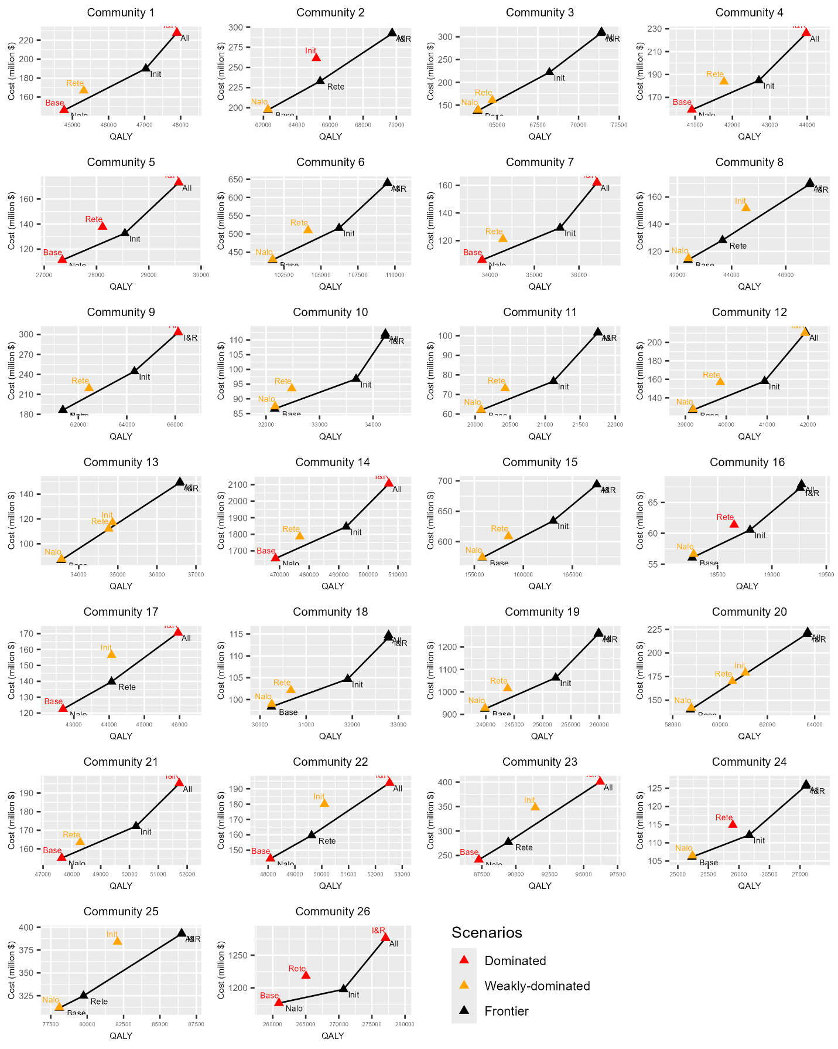
Supplementary Figure 5. Community-level cost-effectiveness frontier results.

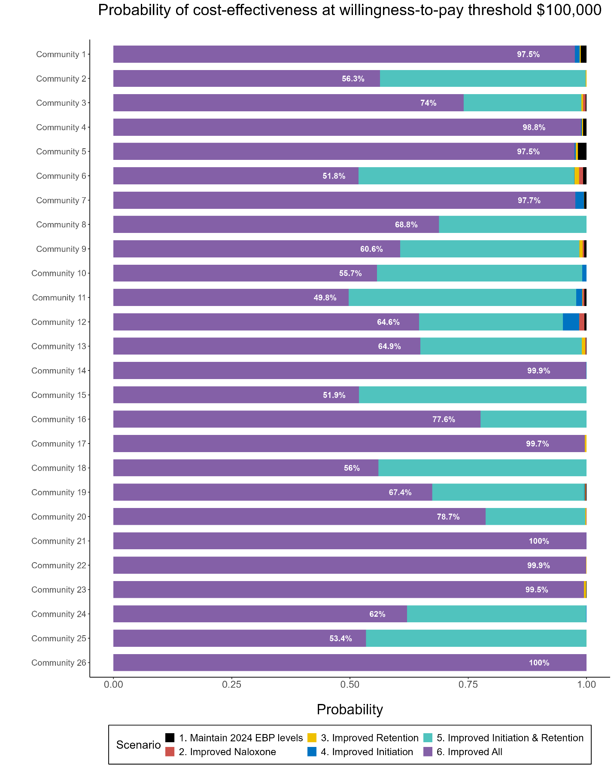
Supplementary Figure 6. Probability of cost-effectiveness for intervention scenarios at a willingness-to-pay threshold of $100,000 per QALY, stratified by community.
Abbreviations: EBP = Evidence-Based Practice.

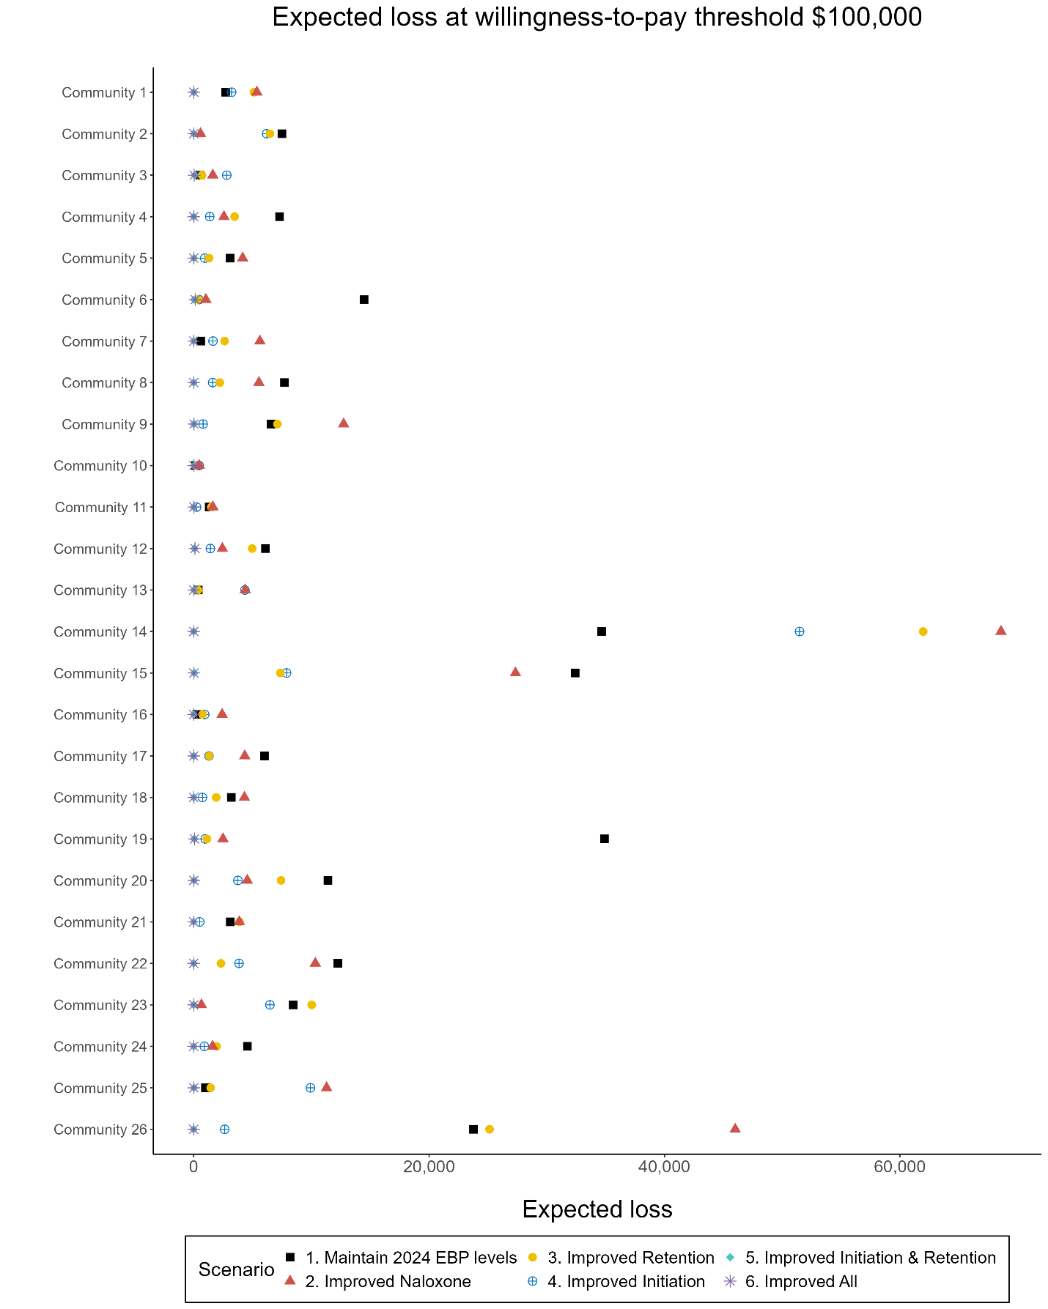
Supplementary Figure 7. Expected loss for intervention scenarios at a willingness-to-pay threshold of $100,000 per QALY, stratified by community.
Abbreviations: EBP = Evidence-Based Practice.
Communities are in order of decreasing OUD prevalence in the “Maintain 2024 EBP Levels” scenario.

References
1. HEALing Communities Study Consortium. The HEALing (Helping to End Addiction Long-term (SM)) Communities Study: Protocol for a cluster randomized trial at the community level to reduce opioid overdose deaths through implementation of an integrated set of evidence-based practices. Drug and alcohol dependence. Dec 1 2020;217:108335. doi:10.1016/j.drugalcdep.2020.108335
2. US Food and Drug Administration. Information about Medication-Assisted Treatment (MAT). Accessed March, 2024. https://www.fda.gov/drugs/information-drug-class/information-about-medication-assisted-treatment-mat
3. Dowd WN, Chen Q, Chhatwal J, et al. Estimating Community-Level Prevalence of Opioid Use Disorder: Extrapolating from Medicaid Claims Data. . 2023
4. Substance Abuse and Mental Health Services Administration (SAMHSA). National Survey on Drug Use and Health. https://www.samhsa.gov/data/data-we-collect/nsduh-national-survey-drug-use-and-health
5. Chadd A, Silvola R, Vorontsova Y, et al. Development of a Natural Language Processing Machine to Enhance Identification of Opioid Use Disorder in Electronic Health Records. Proceedings of IMPRS. 2021;4(1)
6. Ranapurwala SI, Alam IZ, Pence BW, et al. Development and validation of an electronic health records-based opioid use disorder algorithm by expert clinical adjudication among patients with prescribed opioids. Pharmacoepidemiol Drug Saf. May 2023;32(5):577–585. doi:10.1002/pds.5591
7. Substance Abuse and Mental Health Services Administration (SAMHSA). National Survey on Drug Use and Health: 4-Year RDAS (2015 to 2018). Accessed April 18 2023. https://rdas.samhsa.gov/#/survey/NSDUH-2015-2018-RD04YR/.
8. Substance Abuse and Mental Health Services Administration (SAMHSA). National Survey on Drug Use and Health. Accessed May 7, 2023. https://www.samhsa.gov/data/data-we-collect/nsduh-national-survey-drug-use-and-health
9. Substance Abuse and Mental Health Services Administration (SAMHSA). 2016-2018 NSDUH substate region estimates - Tables. Substance Abuse and Mental Health Services Administration. Accessed Jan 17, 2023. https://www.samhsa.gov/data/report/2016-2018-nsduh-substate-region-estimates-tables
10. Substance Abuse and Mental Health Services Administration (SAMHSA). National survey on drug use and health: 2-year RDAS (2016 to 2017) [Data set]. Substance Abuse and Mental Health Data Archive. Accessed Jan 17, 2023. https://rdas.samhsa.gov/#/survey/NSDUH-2016-2017-RD02YR
11. Substance Abuse and Mental Health Services Administration (SAMHSA). National survey on drug use and health: 2-year RDAS (2017 to 2018) [Data set]. Substance Abuse and Mental Health Data Archive. Accessed Jan 17, 2023. https://rdas.samhsa.gov/#/survey/NSDUH-2017-2018-RD02YR
12. Substance Abuse and Mental Health Services Administration (SAMHSA). National survey on drug use and health: 2-year RDAS (2016 to 2017) [Data set]. Substance Abuse and Mental Health Data Archive. Accessed Jan 17, 2023. https://rdas.samhsa.gov/#/survey/NSDUH-2016-2017-RD02YR
13. Substance Abuse and Mental Health Services Administration (SAMHSA). National survey on drug use and health: 2-year RDAS (2017 to 2018) [Data set]. Substance Abuse and Mental Health Data Archive. Accessed Jan 17, 2023. https://rdas.samhsa.gov/#/survey/NSDUH-2017-2018-RD02YR
14. Keyes KM, Rutherford C, Hamilton A, et al. What is the prevalence of and trend in opioid use disorder in the United States from 2010 to 2019? Using multiplier approaches to estimate prevalence for an unknown population size. Drug Alcohol Depend Rep. Jun 2022;3doi:10.1016/j.dadr.2022.100052
15. Mojtabai R. Estimating the Prevalence of Substance Use Disorders in the US Using the Benchmark Multiplier Method. JAMA Psychiatry. Nov 1 2022;79(11):1074–1080. doi:10.1001/jamapsychiatry.2022.2756
16. Chhatwal J, Mueller PP, Chen Q, et al. Estimated Reductions in Opioid Overdose Deaths With Sustainment of Public Health Interventions in 4 US States. JAMA Netw Open. Jun 1 2023;6(6):e2314925. doi:10.1001/jamanetworkopen.2023.14925
17. United States Census Bureau. American Community Survey Data Profiles. Accessed January 17, 2024. https://www.census.gov/acs/www/data/data-tables-and-tools/data-profiles/
18. CDC WONDER. Multiple cause of death 1999-2020. Accessed Jan 1, 2024. http://wonder.cdc.gov/mcd-icd10.html
19. Morgan JR, Schackman BR, Leff JA, Linas BP, Walley AY. Injectable naltrexone, oral naltrexone, and buprenorphine utilization and discontinuation among individuals treated for opioid use disorder in a United States commercially insured population. Journal of substance abuse treatment. 2018;85:90–96.
20. Nosyk B, Li L, Evans E, et al. Utilization and outcomes of detoxification and maintenance treatment for opioid dependence in publicly-funded facilities in California, USA: 1991–2012. Drug and alcohol dependence. 2014;143:149–157.
21. Krebs E, Enns B, Evans E, et al. Cost-effectiveness of publicly funded treatment of opioid use disorder in California. Annals of internal medicine. 2018;168(1):10–19.
22. Fleury M-J, Djouini A, Huỳnh C, et al. Remission from substance use disorders: A systematic review and meta-analysis. Drug and alcohol dependence. 2016;168:293–306.
23. Krebs E, Enns B, Evans E, et al. Cost-Effectiveness of Publicly Funded Treatment of Opioid Use Disorder in California. Ann Intern Med. Jan 2 2018;168(1):10–19. doi:10.7326/m17-0611
24. Nosyk B, Guh DP, Bansback NJ, et al. Cost-effectiveness of diacetylmorphine versus methadone for chronic opioid dependence refractory to treatment. CMAJ. Apr 3 2012;184(6):E317–28. doi:10.1503/cmaj.110669
25. Nosyk B, Anglin MD, Brecht ML, Lima VD, Hser YI. Characterizing durations of heroin abstinence in the California Civil Addict Program: results from a 33-year observational cohort study. Am J Epidemiol. Apr 1 2013;177(7):675–82. doi:10.1093/aje/kws284
26. Nosyk B, MacNab YC, Sun H, et al. Proportional hazards frailty models for recurrent methadone maintenance treatment. American journal of epidemiology. 2009;170(6):783–792.
27. Zang X, Bessey SE, Krieger MS, et al. Comparing projected fatal overdose outcomes and costs of strategies to expand community-based distribution of naloxone in Rhode Island. JAMA Network Open. 2022;5(11):e2241174–e2241174.
28. Santo T, Clark B, Hickman M, et al. Association of opioid agonist treatment with all-cause mortality and specific causes of death among people with opioid dependence: a systematic review and meta-analysis. JAMA psychiatry. 2021;78(9):979–993.
29. IQVIA. IQVIA National Prescription Audit Available from: https://www.iqvia.com/solutions/real-world-evidence/real-world-data-and-insights. 2023;
30. Zang X, Bessey SE, Krieger MS, et al. Comparing Projected Fatal Overdose Outcomes and Costs of Strategies to Expand Community-Based Distribution of Naloxone in Rhode Island. JAMA Netw Open. Nov 1 2022;5(11):e2241174. doi:10.1001/jamanetworkopen.2022.41174
31. Irvine MA, Oller D, Boggis J, et al. Estimating naloxone need in the USA across fentanyl, heroin, and prescription opioid epidemics: a modelling study. Lancet Public Health. Mar 2022;7(3):e210–e218. doi:10.1016/s2468-2667(21)00304-2
32. Larney S, Tran LT, Leung J, et al. All-cause and cause-specific mortality among people using extramedical opioids: a systematic review and meta-analysis. JAMA psychiatry. 2020;77(5):493–502.
33. Arias E, Xu J. United States Life Tables, 2019. Natl Vital Stat Rep. Mar 2022;70(19):1–59.
34. Sordo L, Barrio G, Bravo MJ, et al. Mortality risk during and after opioid substitution treatment: systematic review and meta-analysis of cohort studies. bmj. 2017;357
35. Nosyk B, Guh DP, Bansback NJ, et al. Cost-effectiveness of diacetylmorphine versus methadone for chronic opioid dependence refractory to treatment. Cmaj. 2012;184(6):E317–E328.
36. Wampler DA, Molina DK, McManus J, Laws P, Manifold CA. No deaths associated with patient refusal of transport after naloxone-reversed opioid overdose. Prehosp Emerg Care. 2011;15(3):320–324.
37. Karamouzian M, Kuo M, Crabtree A, Buxton JA. Correlates of seeking emergency medical help in the event of an overdose in British Columbia, Canada: Findings from the Take Home Naloxone program. International Journal of Drug Policy. 2019;71:157–163.
38. Briggs A, Sculpher M, Claxton K. Decision modelling for health economic evaluation. Oup Oxford; 2006.
39. Timko C, Schultz NR, Cucciare MA, Vittorio L, Garrison-Diehn C. Retention in medication-assisted treatment for opiate dependence: A systematic review. J Addict Dis. 2016;35(1):22–35. doi:10.1080/10550887.2016.1100960
40. Wittenberg E, Bray JW, Aden B, Gebremariam A, Nosyk B, Schackman BR. Measuring benefits of opioid misuse treatment for economic evaluation: health‐related quality of life of opioid‐dependent individuals and their spouses as assessed by a sample of the US population. Addiction. 2016;111(4):675–684.
41. Centers for Medicare & Medicaid Services. Calendar Year 2022 National Final Unadjusted Payment Rates for Opioid Treatment Programs. 2021. https://www.cms.gov/files/document/cy-2022-national-final-unadjusted-payment-rates-otps.pdf
42. Department of Veterans Affairs. VA Drug Pricing Database. https://catalog.data.gov/dataset/va-drug-pricing-database
43. Emergent BioSolutions. Emergent BioSolutions’ NARCAN® Nasal Spray Launches Over the Counter Making it Possible for Everyone to Help Save a Life from an Opioid Overdose Emergency. https://investors.emergentbiosolutions.com/news-releases/news-release-details/emergent-biosolutions-narcanr-nasal-spray-launches-over-counter#:~:text=The%20Manufacturer's%20Suggested%20Retail%20Price,to%20roughly%20%2422.50%20per%20dose.
44. Behrends CN, Gutkind S, Winkelstein E, et al. Costs of opioid overdose education and naloxone distribution in New York City. Substance abuse. 2022;43(1):692–698.
45. Centers for Medicare & Medicaid Services. Ambulance Fee Schedule Public Use Files. 2023. https://www.cms.gov/medicare/payment/fee-schedules/ambulance/ambulance-fee-schedule-public-use-files
46. McCollister K, Yang X, Sayed B, French MT, Leff JA, Schackman BR. Monetary conversion factors for economic evaluations of substance use disorders. Journal of substance abuse treatment. 2017;81:25–34.
47. Karaca Z, Moore B. Costs of Emergency Department Visits for Mental and Substance Use Disorders in the United States, 2017. 2020. https://hcup-us.ahrq.gov/reports/statbriefs/sb257-ED-Costs-Mental-Substance-Use-Disorders-2017.pdf
48. Henderson D, Jacobson SH, Johnson AW. The theory and practice of simulated annealing. Handbook of metaheuristics. 2003:287–319.
49. Kirkpatrick S, Gelatt Jr CD, Vecchi MP. Optimization by simulated annealing. science. 1983;220(4598):671–680.
50. Grosse SD, Krueger KV, Pike J. Estimated annual and lifetime labor productivity in the United States, 2016: implications for economic evaluations. Journal of medical economics. 2019;22(6):501–508.
51. U.S. Department of Justice National Drug Intelligence Center. The Economic Impact of Illicit Drug Use on American Society. 2011;
52. Florence CS, Zhou C, Luo F, Xu L. The economic burden of prescription opioid overdose, abuse, and dependence in the United States, 2013. Medical Care. 2016;54(10):901–906.
53. Murphy SM. The cost of opioid use disorder and the value of aversion. Drug and alcohol dependence. 2020;217:108382.
54. Gauthier P, Greco P, Meyers-Ohki S, Desai A, Rotrosen J. Patients' perspectives on initiating treatment with extended-release naltrexone (XR-NTX). Journal of Substance Abuse Treatment. 2021;122:108183.

Note: Buprenorphine is also available as a six-month implant, but it represents a very small proportion of buprenorphine provided to Medicaid beneficiaries and was excluded from this analysis. The days supplied computation assumed that buprenorphine and naltrexone (i.e., Vivitrol) injections lasted 30 days.
The constraints were applied along with a scaling factor that applied equally to each of the five state-specific costs. This had the effect of constraining the relative costs among states based on NSDUH but not the absolute values.
Grosse and colleagues define non-market productivity as “performing household activities, caring and helping people, consumer purchases, volunteer activities, secondary childcare, and […] secondary eldercare.”
For example, this implies that productivity for someone in the RX state was assumed to be 93.7% of someone of the same age and sex in the recovery state, which was assumed to have no decrement. Thus, the cost for being in the RX state was 6.3% of the full productivity estimate from Grosse et al. (2019).
Utilities were derived from responses to the SF-12, see Brazier, J. E., & Roberts, J. (2004). The estimation of a preference-based measure of health from the SF-12. Medical care, 42(9), 851-859.

